Tech TFQ Youtuber/https://techtfq.com/blog/learn-how-to-write-sql-queries-practice-complex-sql-queries

1. **Write a SQL Query to fetch all the duplicate records in a table.**

**Table Name**: TEMP_USERS

**Note**: Record is considered duplicate if a user name is present more than once.

**Approach**: Partition the data based on user name and then give a row number to each of the partitioned user name. If a user name exists more than once then it would have multiple row numbers. Using the row number which is other than 1, we can identify the duplicate records.

TEMP_USERS

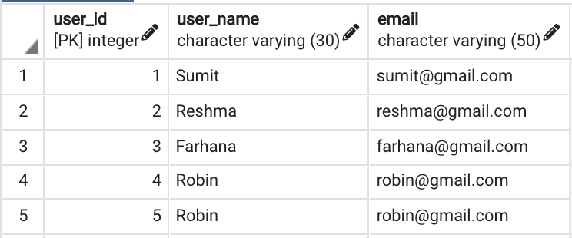

**Expected Output**

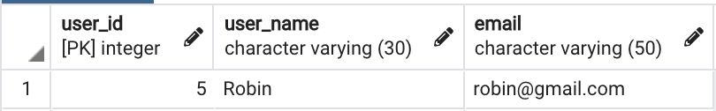

Solution Query:

select user_id, user_name, email from (

select *, ROW_NUMBER() over (partition by user_name order by user_id) rn from temp_user) x

where x.rn > 1;

**2. Write a SQL query to fetch the second last record from employee table.**

**Table Name**: EMPLOYEE

**Approach**: Using window function sort the data in descending order based on employee id. Provide a row number to each of the record and fetch the record having row number as 2.

EMPLOYEE  
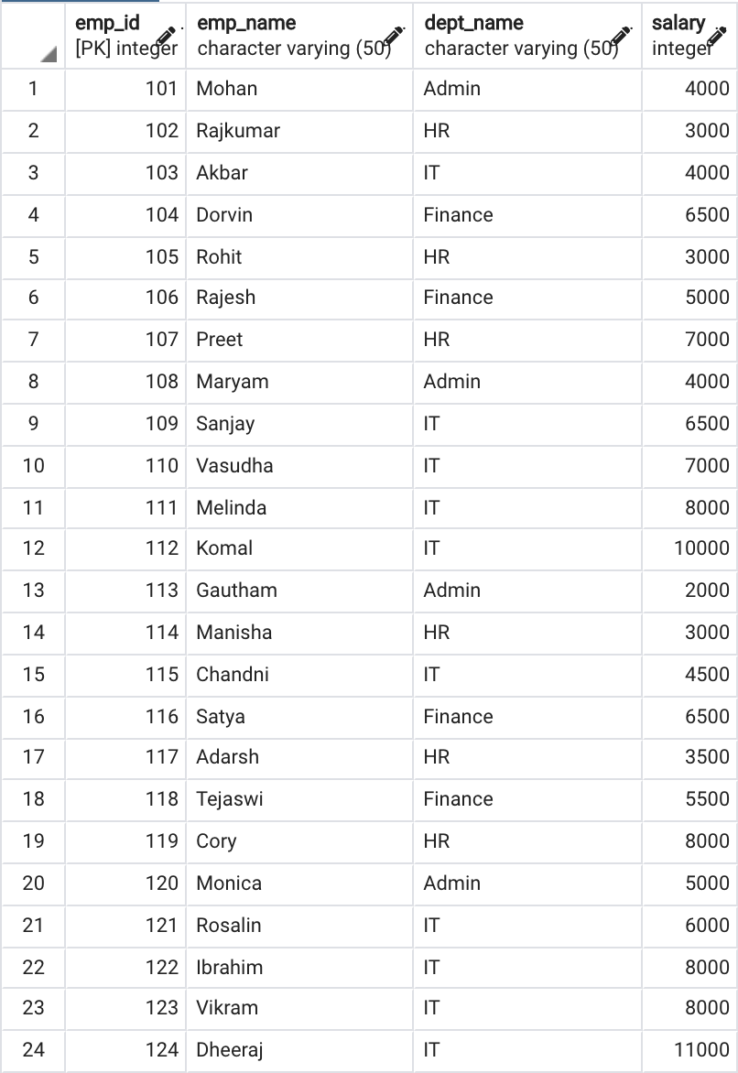

**Expected Output**

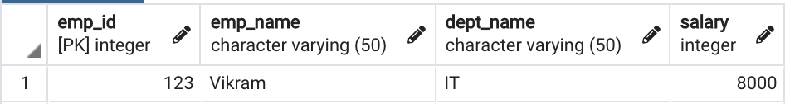

Solution Query:

Select emp_id, emp_name, dept_name, salary from (

Select *, row_number() over( order by emp_id desc) rn from EMPLOYEE ) x where x.rn = 2;

**3. Write a SQL query to display only the details of employees who either earn the highest salary or the lowest salary in each department from the employee table.**

**Table Name**: EMPLOYEE

**Approach**: Write a sub query which will partition the data based on each department and then identify the record with maximum and minimum salary for each of the partitioned department. Finally, from the main query fetch only the data which matches the maximum and minimum salary returned from the sub query.

EMPLOYEE

**Expected Output**

Solution Query:

select emp_id, emp_name, e.dept_name, e.salary, x.max_sal, x.min_sal from employee e,

(select dept_name, min(salary) min_sal, max(salary) max_sal from employee group by dept_name ) x

where x.dept_name = e.dept_name and e.salary in (x.min_sal, x.max_sal);

**4. From the doctors table, fetch the details of doctors who work in the same hospital but in different specialty.**

**Table Name**: DOCTORS

**Approach**: Use self join to solve this problem. Self join is when you join a table to itself.

**Additional Query**: Write SQL query to fetch the doctors who work in same hospital irrespective of their specialty.

DOCTORS

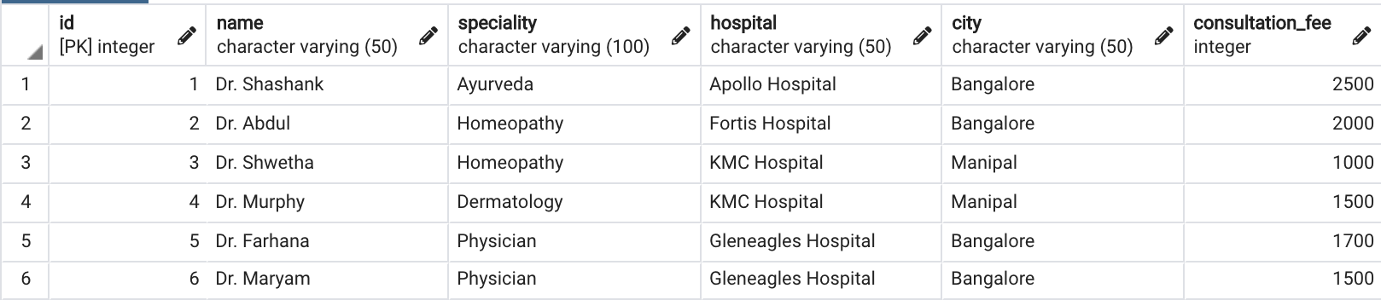

**Expected Output:** Same hospital different speciality

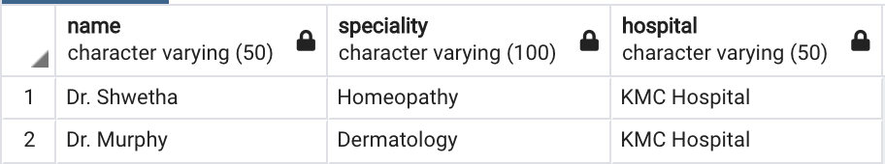

**Expected Output:** Same hospital irrespective of speciality

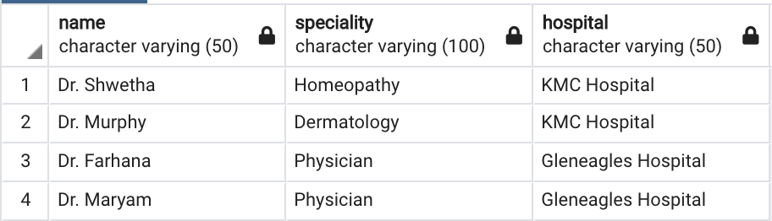

Solution Query:

select D1.* FROM DOCTORS D1, DOCTORS D2 where D1.HOSPITAL=D2.HOSPITAL and D1.SPECIALITY <> D2.SPECIALITY;

or

SELECT D1.* FROM DOCTORS D1 JOIN DOCTORS D2 ON D1.HOSPITAL=D2.HOSPITAL and D1.SPECIALITY <> D2.SPECIALITY;

SELECT * FROM DOCTORS D1,

(SELECT HOSPITAL, COUNT(HOSPITAL) CNT FROM DOCTORS GROUP BY HOSPITAL HAVING COUNT(HOSPITAL) > 1 ) D2

where D1.HOSPITAL = D2.HOSPITAL;

**5. From the login_details table, fetch the users who logged in consecutively 3 or more times.**

**Table Name**: LOGIN_DETAILS

**Approach**: We need to fetch users who have appeared 3 or more times consecutively in login details table. There is a window function which can be used to fetch data from the following record. Use that window function to compare the user name in current row with user name in the next row and in the row following the next row. If it matches then fetch those records.

LOGIN_DETAILS

**Expected Output**

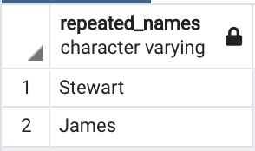  
Solution:

with cte as

(select *,

case when user_name = lead(user_name) over (order by login_id) -- here we compare the current record user name with next record user name

and user_name = lead(user_name, 2) over (order by login_id) -- here we gave offset 2 in lead function to check next to next record

then user_name -- if both the above conditions are true we get user name else null in repeated_users columns

else null

end as repeated_users

from LOGIN_DETAILS )

select distinct user_name from cte where repeated_users is not null;

**6. From the students table, write a SQL query to interchange the adjacent student names.**

**Note**: If there are no adjacent student then the student name should stay the same.

**Table Name**: STUDENTS

**Approach**: Assuming id will be a sequential number always. If id is an odd number then fetch the student name from the following record. If id is an even number then fetch the student name from the preceding record. Try to figure out the window function which can be used to fetch the preceding the following record data.

If the last record is an odd number then it wont have any adjacent even number hence figure out a way to not interchange the last record data.

STUDENTS

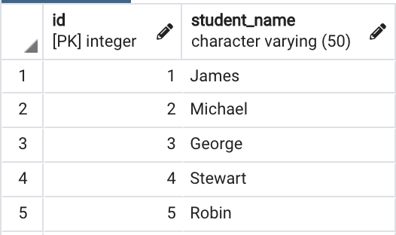

**Expected Output**

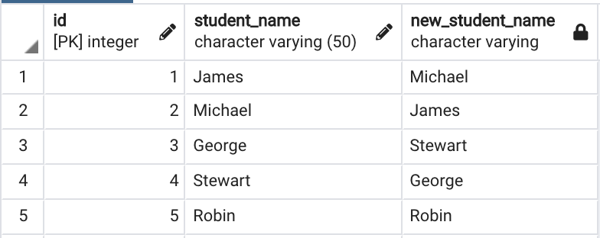

**Solution**:

select *,

case when id%2 <> 0

then lead(student_name,1,student_name) over (order by id)

else lag(student_name) over (order by id)

end as adjacent_student

from STUDENTS;

**7. From the weather table, fetch all the records when London had extremely cold temperature for 3 consecutive days or more.**

**Note**: Weather is considered to be extremely cold when its temperature is less than zero.

**Table Name**: WEATHER

**Approach**: First using a sub query identify all the records where the temperature was very cold and then use a main query to fetch only the records returned as very cold from the sub query. You will not only need to compare the records following the current row but also need to compare the records preceding the current row. And may also need to compare rows preceding and following the current row. Identify a window function which can do this comparison pretty easily.

WEATHER

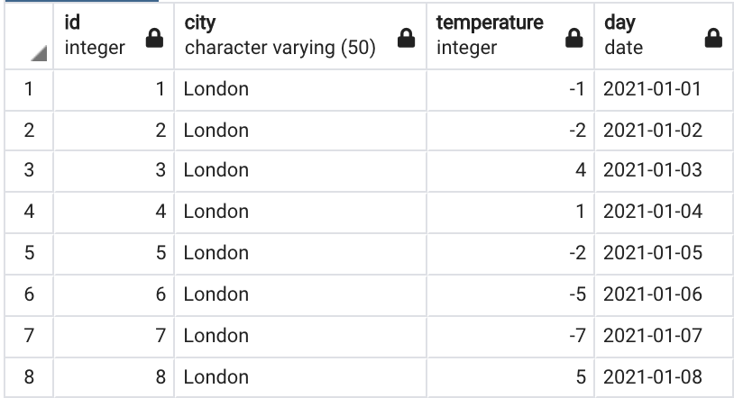

**Expected Output**

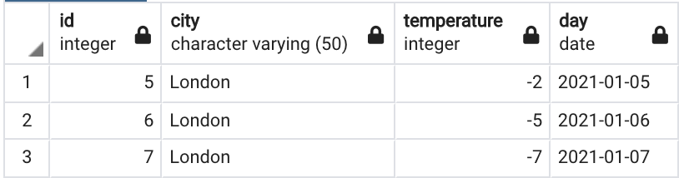

SOLUTION:

with cte as

(select *,

case

when temperature < 0 --current day should be less than 0

and lead (temperature, 1) over (order by day) < 0 -- next day should be less than 0 as well

and lead(temperature, 2) over (order by day) < 0 --next to next day also should be less than 0

then 'YES'

when temperature < 0 --current day should be less than 0

and lag (temperature) over (order by day) < 0 --previous day should be less than 0

and lead(temperature) over (order by day) < 0 --next day should be less than 0

then 'YES'

when temperature < 0 --current day should be less than 0

and lag (temperature, 1) over (order by day) < 0 --previous day should be less than 0

and lag(temperature, 2) over (order by day) < 0 --2 days prior also shouls be less than 0

then 'YES'

else null

end extreme_day

from weather)

select id, city, temperature, day from cte where extreme_day = 'YES'-- dump all the days which are extreme weather set of 3 days;

**8. From the following 3 tables (event_category, physician_speciality, patient_treatment), write a SQL query to get the histogram of specialties of the unique physicians who have done the procedures but never did prescribe anything.**

**Table Name**: EVENT_CATEGORY, PHYSICIAN_SPECIALITY, PATIENT_TREATMENT

**Approach**: Using the patient treatment and event category table, identify all the physicians who have done “Prescription”. Have this recorded in a sub query.

Then in the main query join the patient treatment, event category and physician speciality table to identify all the physician who have done “Procedure”. From these physicians, remove those physicians you got from sub query to return the physicians who have done Procedure but never did Prescription.

PATIENT_TREATMENT

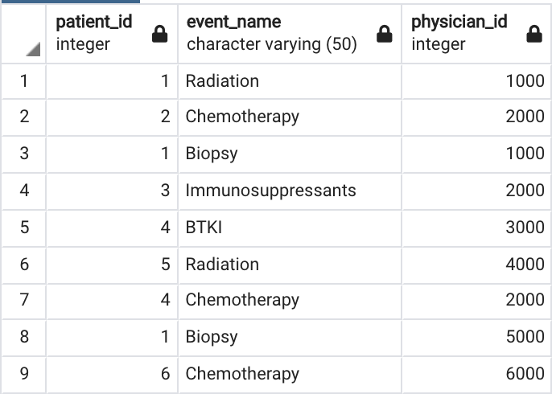

EVENT_CATEGORY

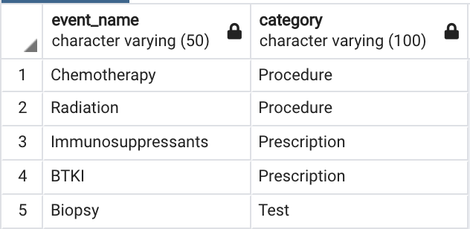

PHYSICIAN_SPECIALITY

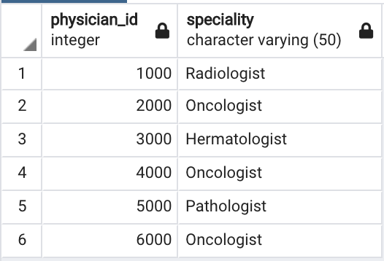

**Expected Output**

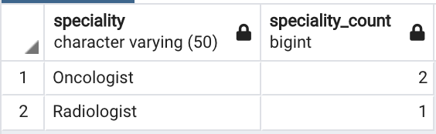

Solution:

with cte3 as

(select PT.physician_id from PATIENT_TREATMENT PT join EVENT_CATEGORY EC

on PT.event_name = EC.event_name

and EC.category = 'Prescription')

select PS.speciality, count(1)

from PHYSICIAN_SPECIALITY PS

join PATIENT_TREATMENT PT on PS.physician_id = PT.physician_id

join EVENT_CATEGORY EC on PT.event_name = EC.event_name

and EC.category = 'Procedure'

and PS.physician_id not in (select physician_id from cte3) group by PS.speciality ;

**9. Find the top 2 accounts with the maximum number of unique patients on a monthly basis.**

**Note**: Prefer the account id with the least value in case of same number of unique patients

**Table Name**: PATIENT_LOGS

**Approach**: First convert the date to month format since we need the output specific to each month. Then group together all data based on each month and account id so you get the total no of patients belonging to each account per month basis.

Then rank this data as per no of patients in descending order and account id in ascending order so in case there are same no of patients present under multiple account if then the ranking will prefer the account if with lower value. Finally, choose upto 2 records only per month to arrive at the final output.

PATIENT_LOGS

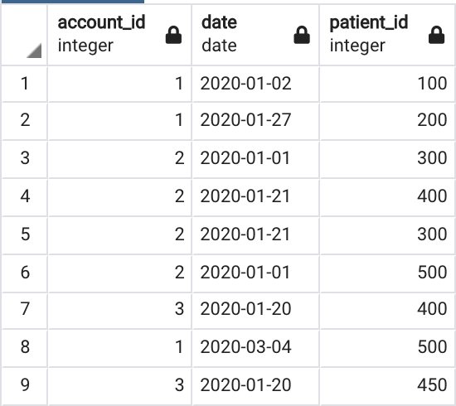

**Expected Output**

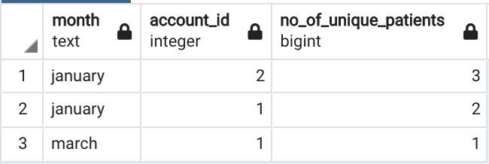

Solution:

select mnth, account_id, cnt from

(select X.account_id, X.mnth, count(X.patient_id) cnt, RANK() over (partition by mnth order by count(X.patient_id) desc, account_id ) rnk

from

(select account_id, MONTH(treatment_date) mnth, patient_id

from PATIENT_LOGS

group by MONTH(treatment_date), account_id, patient_id )

X group by account_id, mnth ) Z

where rnk <=2 order by mnth, account_id desc

**10. SQL Query to fetch “N” consecutive records from a table based on a certain condition**

Note: Write separate queries to satisfy following scenarios:

10a. when the table has a primary key

Table Name: WEATHER

**WEATHER table Data**

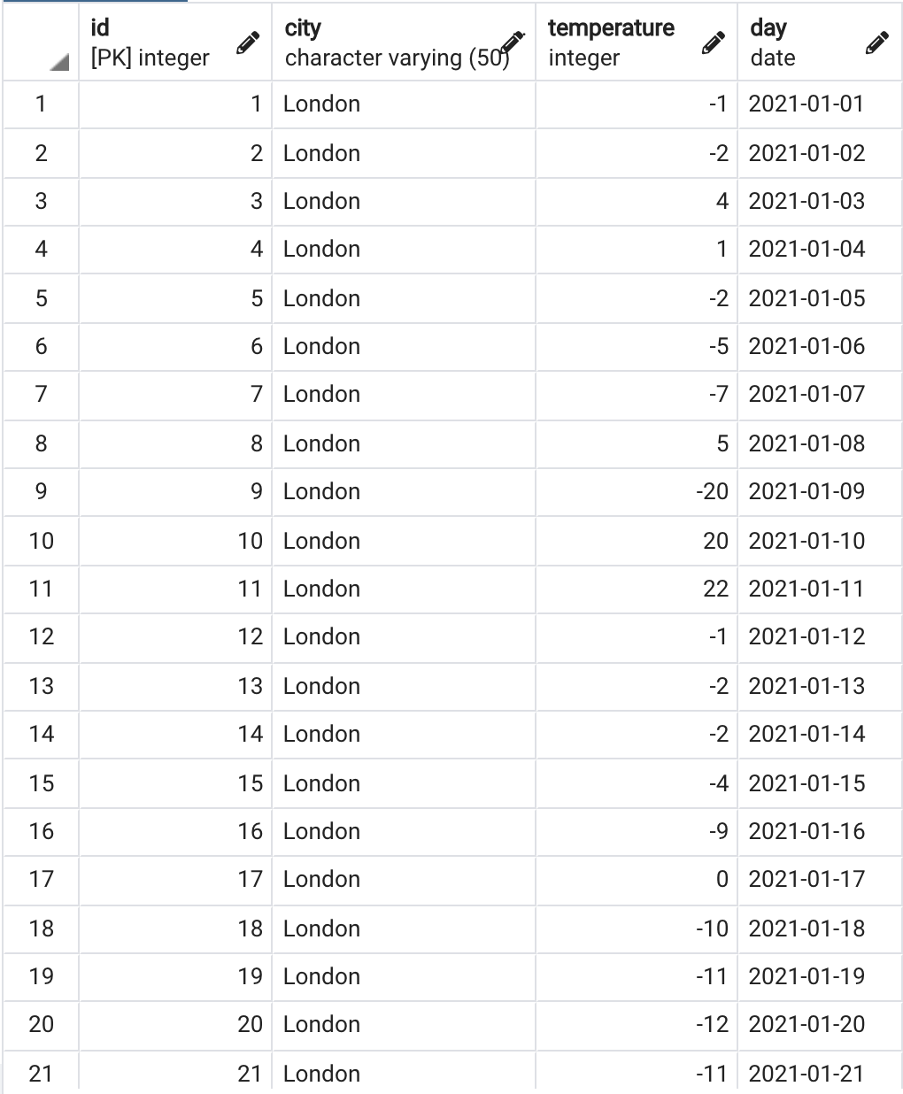

**10a: Expected Output**

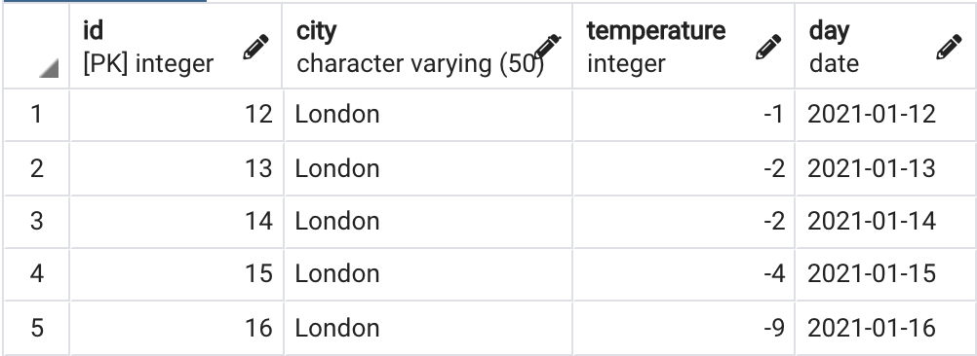

Solution:

/*

1) we need to eliminate the days where temp is > 0 and consider only <0 records

select * from WEATHER1 where temp <0;

2) assign a row muner for each record in the table order by id since id is a primary key and in sequence

select *,ROW_NUMBER() over (order by id) from WEATHER1 where temp <0

3) the difference between consecutive days of id and row_number will remain same as ids are in sequence

select *,id - ROW_NUMBER() over (order by id) from WEATHER1 where temp <0

4) put the above data in a subquery

4) now partition the records by number of difference of id and row_number count and give an alian like cnt

5) now fetch cnt = N based on N value

*/

with T11 as

(select *,id - ROW_NUMBER() over (order by id) difference from WEATHER1

where temp <0),

T12 as

(select *, count(*) over (partition by difference order by difference ) cnt from T11)

select id, city, temp, recorded_day from T12

where cnt = X; --X can be any consecutive value…

10b. When table does not have a primary key

Table Name: VW_WEATHER

**VW_WEATHER table data**

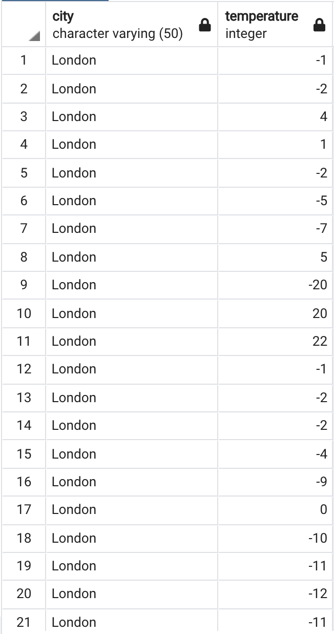

**10b: Expected Output**

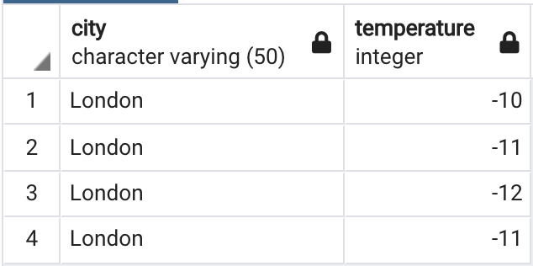

Solution:

/*

1) Lets create view without id column and only non-zero records

create view weather_vw as select city, temp from WEATHER1

2) Now that the view doesnt have id/PK column, create a subquery with clause add a row_num column, it will work as id

3) proceed as 10.a

*/

create view weather_vw as select city, temp from WEATHER1;

select * from weather_vw;

with

w as

(select *, row_number() over (order by city) as id

from weather_vw),

t1 as

(select *, id - row_number() over (order by id) as diff

from w

where w.temp < 0),

t2 as

(select *,

count(*) over (partition by diff order by diff) as cnt

from t1)

select city, temp, id, cnt

from t2

where t2.cnt = 5;

10c. Query logic based on data field

Table Name: ORDERS

**ORDERS table data**

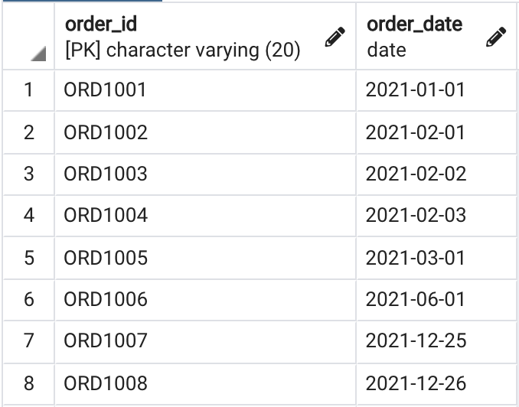

**10c: Expected Output**

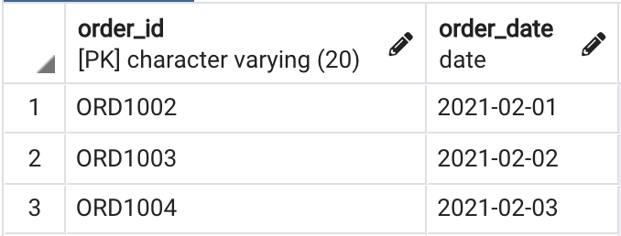

Solution:

/* 1) since the data doesnt have an id column, lets add one by using Row_num function, and put it in an alias

select *, ROW_NUMBER () over (order by ORDER_ID) id from ORDERS

2) Now, subtract the ROW_NUM function from order_date to get a unique difference like we did in previous queries.

(select *, ROW_NUMBER () over (order by ORDER_ID) id, DATEADD(day,-ROW_NUMBER () over (order by ORDER_ID),ORDER_DATE) difference from ORDERS)

3) create a count based on each unique partition in another subquery

4) finally fetch the records based on count X

*/

select * from orders;

with

a1 as

(select *, ROW_NUMBER () over (order by ORDER_ID) id, DATEADD(day,-ROW_NUMBER () over (order by ORDER_ID),ORDER_DATE) difference from ORDERS),

a2 as

(select *, count(order_id) over (partition by difference) cnt from a1 )

select * from a2

where cnt = 3;

/* Amazon and Big4 interview qn:

11. Employee attendance register: need a from and to dates of all status log, for example if employee is present

Between 1st to 3rd of Jan, and then absent on 4th... we should have two records showing like below

EMPLOYEE FROM_DATE TO_DATE STATUS

A1 2024-01-01 2024-01-03 PRESENT

A1 2024-01-04 2024-01-04 ABSENT

A1 2024-01-05 2024-01-06 PRESENT

A1 2024-01-07 2024-01-09 ABSENT

etc */

create table employee_1 (employee varchar(2), dates date, status varchar(10));

insert into employee_1 values('A1', '2024-01-01', 'PRESENT');

insert into employee_1 values('A1', '2024-01-02', 'PRESENT');

insert into employee_1 values('A1', '2024-01-03', 'PRESENT');

insert into employee_1 values('A1', '2024-01-04', 'ABSENT');

insert into employee_1 values('A1', '2024-01-05', 'PRESENT');

insert into employee_1 values('A1', '2024-01-06', 'PRESENT');

insert into employee_1 values('A1', '2024-01-07', 'ABSENT');

insert into employee_1 values('A1', '2024-01-08', 'ABSENT');

insert into employee_1 values('A1', '2024-01-09', 'ABSENT');

insert into employee_1 values('A1', '2024-01-10', 'PRESENT');

insert into employee_1 values('A2', '2024-01-06', 'PRESENT');

insert into employee_1 values('A2', '2024-01-07', 'PRESENT');

insert into employee_1 values('A2', '2024-01-08', 'ABSENT');

insert into employee_1 values('A2', '2024-01-09', 'PRESENT');

insert into employee_1 values('A2', '2024-01-10', 'ABSENT');

select * from employee_1;

with sq1 as

(select *, ROW_NUMBER() over (partition by status, employee order by dates) id

from employee_1),

sq2 as

(select *, DATEADD(day,-id,dates) diff from sq1)

select employee, min(dates) from_date, max(dates) to_date, status from sq2

group by diff, employee, status order by employee, from_date;

--alterante approach--

with sq1 as

(select *, ROW_NUMBER() over (partition by status, employee order by dates) id

from employee_1),

sq2 as

(select *, DATEADD(day,-id,dates) diff from sq1),

sq3 as

--select * from sq2;

(select *,

FIRST_VALUE(dates) over (partition by diff, employee order by employee) as FROM_DATE,

--FIRST_VALUE is a default window function, which returen first value of argument we passed based on partition

LAST_VALUE(dates) over (partition by diff, employee order by employee

range between unbounded preceding and unbounded following) as TO_DATE --this line is a standard syntax to get last value to avoid default frame clause

from SQ2)

select distinct employee, FROM_DATE, TO_DATE, STATUS

from SQ3 order by employee, FROM_DATE;

/*--------------------------Window functions--------------------------------*/

select * from employee;

--display max sal by each dept

select dept_name, max(salary) max_sal from employee group by dept_name;

--here we didnt display the rest of the values... in case we need to show the max sal for each record,

--thats when window functions come into picture. see example below.

select *, max(salary) over (partition by dept_name) from employee;

--there will be partitions created based on the column specified (in this case its dept_name)

--and aggregate function(in this case its max function) will be executed on each partition

--row_num, rank, dense_rank, lead, lag

--are functions, which just assign a value for each record which has been detected/identified by the arguments

--mentioned in over clause, thats why we dont pass any argument inside the function name unline aggregate functions.

select *, ROW_NUMBER() over (order by emp_id) rownum from employee; --order by is mandatory in row_number function in sql server,

--in this case it can be used as a PK to uniquely identify every record in the table.

--we can create windows for each partition and then given row_numbers as well

select *, ROW_NUMBER() over (partition by dept_name order by emp_id) rownum from employee;

--lets say use case where they need first two employees joined in each dept, here row_number is useful.

select * from

(select *, row_number() over (partition by dept_name order by emp_id) rownum from employee ) x

where x.rownum < 3;

--RANK ; duplicate values will have same rank and next number will be skipped.

--Fetch top 3 sal in each dept

select *, rank() over (partition by dept_name order by salary desc) ranks from employee; -- will assign ranks to

--each employee based on salary, we just need to pick top 3 salaries from above

select * from

(select *, rank() over (partition by dept_name order by salary desc) ranks from employee) y

where y.ranks <=3;

--similarly faq is find nth max salary from table, lets see how we can build it below.

select * from

(select *, rank() over (order by salary desc) ranks from employee) y

where y.ranks = 15; -- here 4 can be replaced by any rank within table

--dense_rank... same as rank but when duplicate values encountered, next rank will not be skipped...

--lets see all rank, dense_rank, and row_number in one example

--you may observe the difference at records with salary 2000 below.

select *,

rank() over (order by salary desc) ranks,

dense_rank() over (order by salary desc) dense,

row_number() over (order by salary desc) rownum

from employee;

--lead and lag

--sal of current employee is higher/lower than next/prev employee

--LEAD: will always have last record null, it has 4 arguments

-- 1) on which column the function need to perform

-- 2) what is the skip value... by default 1, e.g: if we give 2, it will compare the following second record.

-- 3) default value to replace the last record

-- 4) over function in general to define windows and orders

select *, lead(salary,1,9999) over (order by emp_id) next_emp_sal from employee;

--similarly check per dept by creating paritions

select *, lead(salary) over (partition by dept_name order by emp_id) next_emp_sal from employee;

--lag is also similar but as name suggest it will check with previous record and display in window...

select *, lag(salary) over (partition by dept_name order by emp_id) next_emp_sal from employee;

--lets see how we can display some meaningful summary based on lead, lag for salary comparision

select *,

case

when salary < lead(salary) over (partition by dept_name order by emp_id)

then 'Lower Salary than next employee'

when salary > lead(salary) over (partition by dept_name order by emp_id)

then 'Higher Salary than next employee'

when salary = lead(salary) over (partition by dept_name order by emp_id)

then 'Equal Salary as next employee'

else NULL

end next_emp_sal

from employee;

/*--------------------------------------------------------------------------*/

/* Windows functions advanced topics */

CREATE TABLE product

(

product_category varchar(255),

brand varchar(255),

product_name varchar(255),

price int

);

INSERT INTO product VALUES

('Phone', 'Apple', 'iPhone 12 Pro Max', 1300),

('Phone', 'Apple', 'iPhone 12 Pro', 1100),

('Phone', 'Apple', 'iPhone 12', 1000),

('Phone', 'Samsung', 'Galaxy Z Fold 3', 1800),

('Phone', 'Samsung', 'Galaxy Z Flip 3', 1000),

('Phone', 'Samsung', 'Galaxy Note 20', 1200),

('Phone', 'Samsung', 'Galaxy S21', 1000),

('Phone', 'OnePlus', 'OnePlus Nord', 300),

('Phone', 'OnePlus', 'OnePlus 9', 800),

('Phone', 'Google', 'Pixel 5', 600),

('Laptop', 'Apple', 'MacBook Pro 13', 2000),

('Laptop', 'Apple', 'MacBook Air', 1200),

('Laptop', 'Microsoft', 'Surface Laptop 4', 2100),

('Laptop', 'Dell', 'XPS 13', 2000),

('Laptop', 'Dell', 'XPS 15', 2300),

('Laptop', 'Dell', 'XPS 17', 2500),

('Earphone', 'Apple', 'AirPods Pro', 280),

('Earphone', 'Samsung', 'Galaxy Buds Pro', 220),

('Earphone', 'Samsung', 'Galaxy Buds Live', 170),

('Earphone', 'Sony', 'WF-1000XM4', 250),

('Headphone', 'Sony', 'WH-1000XM4', 400),

('Headphone', 'Apple', 'AirPods Max', 550),

('Headphone', 'Microsoft', 'Surface Headphones 2', 250),

('Smartwatch', 'Apple', 'Apple Watch Series 6', 1000),

('Smartwatch', 'Apple', 'Apple Watch SE', 400),

('Smartwatch', 'Samsung', 'Galaxy Watch 4', 600),

('Smartwatch', 'OnePlus', 'OnePlus Watch', 220);

--FIRST_VALUE : function extracts very first record value from a partition mentioned in the function.

--E.g: write a query to display the most expensive product under each category (corresponding to each record).

select *,

first_value(product_name) over (partition by product_category order by price desc) most_exp_prod

from product;

--LAST VALUE: function extracts very last record value from a partition mentioned in the function.

--write a query to display the least expensive product under each category (corresponding to each record).

select *,

last_value(product_name) over (partition by product_category order by price desc) least_exp_prod

from product;

/*writing the query like first_value is not going to help here .... because of frame clause

FRAME Clause: when data is divided into partition, when controller read data in each partition, it treats them in frames.

each frame can be defined by combination of considering from first record in the partition to end of the last record

in the parition. Then on that frame entire last_value function will be applied.

condition to built tha frame is by using "range between unbounded preceding and unbounded following", this will tell controller

that use the entire partition from first record to last.

defaule behavior condition is "range between unbounded preceeding and current row following"... in our result set, since we

didnt mention any condition inside last_value over clause, it has taken default and as every new record is being added

into the frame, it is showing new least_exp_prod.

We can change keyword from 'range' to 'row', which will give different results when duplicate values present in data.

Instead of unbounded, we can give numeric value, and controller will consider only those number of records.

Lets see below with range condition to tell the FRAME to use entire parition

*/

select *,

last_value(product_name) over (partition by product_category order by price desc

range between unbounded preceding and unbounded following) least_exp_prod

from product;

--lets display both most expensive and least expensive in same query

select *,

first_value(product_name) over (partition by product_category order by price desc) most_exp_prod,

last_value(product_name) over (partition by product_category order by price desc

range between unbounded preceding and unbounded following) least_exp_prod

from product;

--here if we are using same OVER() function multiple times in a query, it can be shorted by below alternate approach

select *,

first_value(product_name) over W most_exp_prod,

last_value(product_name) over W least_exp_prod

from product

window W as (partition by product_category order by price desc

range between unbounded preceding and unbounded following) ;

--another alternate approach to get the results using just FIRST_VALUE

select *,

first_value(product_name) over (partition by product_category order by price desc) most_exp_prod,

first_value(product_name) over (partition by product_category order by price ) least_exp_prod

from product;

--NTH_Value: Similar to FIRST and LAST Value, will result Nth value in the partition/table

--second most expensive product

--in sql server its not there, and nth_value also depends on frame clause

select *,

first_value(product_name) over W most_exp_prod,

last_value(product_name) over W least_exp_prod,

nth_value(product_name, 2) over W second_most_exp_product

from product

window W as (partition by product_category order by price desc

range between unbounded preceding and unbounded following) ;

--NTILE: used to group data in certain partition and treat it as a bucket based on single numric argument we pass;

--mostlikely SQL will create equal number of buckets, if not will distribute rows to one bucket at a time.

--write a query to categorize phones in expensive, mid-range and cheper phones buckets

select * ,

NTILE(3) OVER (order by price )

from product ;

with CTE as

(select * ,

NTILE(3) OVER (order by price ) TILE

from product)

select *,

case

when TILE = 1 then 'cheper phone'

when TILE = 2 then 'mid range phone'

when TILE = 3 then 'expensive phone'

end phone_Category

from CTE

where product_category='Phone';

/*CUME_DIST: (cumulative distribution)

value --> 1 <= CUME_DIST >0

FORMULA = current rownum (or rownum with value same as current row num) /Total num of rows

basically if each row position will be divided by total number of rows.*/

--Query to fetch all records which constitutes first 30% of table based on price

with X as

(select *,

CUME_DIST() over (order by price desc) cum_dist, -- will display in fractions, we need to convert into numeric by below

round(CUME_DIST() over (order by price desc)*100, 2) cum_dist_percentage

from product )

select product_name, concat(cum_dist_percentage,'%' )

from X

where cum_dist_percentage <= 30 ;

/*PERCENT_RANK (relative rank of the current row/percentage ranking)

value --> 1 <= PERCENT_RANK > 0

FORMULA: Current row num -1 / Total number of rows -1

*/

--Query to find out how much percentage more expensive is 'Galaxy Z fold 3' when compared to all other products

WITH K as

(select *,

PERCENT_RANK() over (order by price ) percent_rank, -- this displays in fractions, we need to convert to numbers

round(PERCENT_RANK() over (order by price )*100, 2) percent_rank_num

from product)

select percent_rank_num from K where product_name = 'Galaxy Z Fold 3';

/*--------------------------------------------------------------------------*/

/* Recursive Queries

Syntax:

with [Recursive] --recursive key word is optional in some of the databases

CTE_NAME as

(

select query -- this is non recursive query or base query

union [all] -- union all is optional in some of the databases

select query (recursive query using CTE_NAME [with a termination condition])

)

select * from CTE_NAME

*/

--Q1. Return numbers 1 to 10 without using any built in functions

WITH

CTE AS

( select 1 num

union all

select num+1 from CTE

where num < 10

)

select * from CTE;

--Q2. Find the hierarchy of employees under a given manager

create table emp_details (id int primary key, emp_name varchar(20), manager_id int, salary int, designation varchar(20));

insert into emp_details values (1, 'Shripadh', NULL , 10000, 'CEO');

insert into emp_details values (2, 'Satya', 5 , 1400, 'Software Engineer');

insert into emp_details values (3, 'Jia', 5 , 500, 'Data Analyst');

insert into emp_details values (4, 'David', 5 , 1800, 'Data Scientist');

insert into emp_details values (5, 'Michael', 7 , 3000, 'Manager');

insert into emp_details values (6, 'Arvind', 7 , 2400, 'Architect');

insert into emp_details values (7, 'Asha', 1 , 4200, 'CTO');

insert into emp_details values (8, 'Maryam', 1 , 3500, 'Manager');

insert into emp_details values (9, 'Reshma', 8 , 2000, 'Business Analyst');

insert into emp_details values (10, 'Akshay', 8 , 2500, 'Java Developer');

select * from emp_details

where manager_id = 7;

with rec_manager_emp as

(select id, emp_name, manager_id, designation,1 lvl from emp_details where emp_name = 'Asha'

union all

select E.id, E.emp_name, E.manager_id, E.designation, H.lvl+1 from rec_manager_emp H

join emp_details E

on H.id = E.manager_id)

select * from rec_manager_emp;

--Q3. Find the hierarchy of managers for a given employee

with rec_emp_manger as

(select id, emp_name, manager_id, designation, 1 lvl from emp_details where emp_name = 'David'

union all

select E.id, E.emp_name, E.manager_id, E.designation, H.lvl+1 from rec_emp_manger H

join emp_details e

on H.manager_id = e.id)

select H2.emp_name EMP_NAME, E2.EMP_NAME MANAGER_NAME, H2.DESIGNATION, H2.LVL from rec_emp_manger H2

join emp_details E2 on

E2.id = H2.manager_id;

/*--------------------------------------------------------------------------*/

Expected O/P:

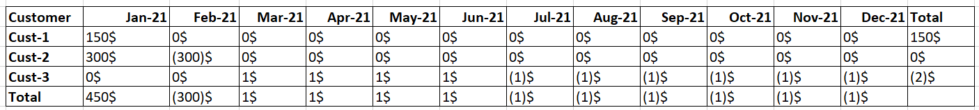

--Output at this step looks like below.

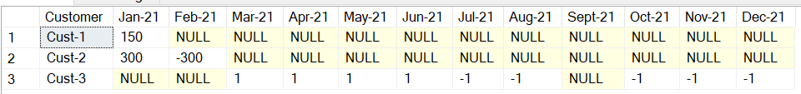

select * from

(select customer_id as Customer,

FORMAT(sales_date, 'MMM-yy') as sales_date,

cast(replace(amount,'$','') as int) as amount

from sales_data) as sales_data --(since sql server needs alias for a subquery

pivot

(--aggregate function :here we want to sum the amount so

sum(amount)

--for columns values to be selected --(in this case its like "Jan-21", "Feb-21", "Mar-21", ...etc)

for sales_date in ( [Jan-21],[Feb-21],[Mar-21],[Apr-21],[May-21],[Jun-21],

[Jul-21],[Aug-21],[Sept-21],[Oct-21],[Nov-21],[Dec-21] )

) as pivot_table

-- at this point we need to build the same data for TOTAL record so join the above data with additional data by union

UNION

select * from

(select 'Total' as Customer,

FORMAT(sales_date, 'MMM-yy') as sales_date,

cast(replace(amount,'$','') as int) as amount

from sales_data) as sales_data --(since sql server needs alias for a subquery

pivot

(--aggregate function :here we want to sum the amount so

sum(amount)

--for columns values to be selected --(in this case its like "Jan-21", "Feb-21", "Mar-21", ...etc)

for sales_date in ( [Jan-21],[Feb-21],[Mar-21],[Apr-21],[May-21],[Jun-21],

[Jul-21],[Aug-21],[Sept-21],[Oct-21],[Nov-21],[Dec-21] )

) as pivot_table

--once the total is added, the o/p looks like below

--now we need to remove nulls and treat them as 0s, it can by done by coalesce in sql server; we need to build it

--from existing result set so, lets give it an alias name inside with clause now.

with pivot_data as

(

select * from

(select customer_id as Customer,

FORMAT(sales_date, 'MMM-yy') as sales_date,

cast(replace(amount,'$','') as int) as amount

from sales_data) as sales_data --(since sql server needs alias for a subquery

pivot

(--aggregate function :here we want to sum the amount so

sum(amount)

--for columns values to be selected --(in this case its like "Jan-21", "Feb-21", "Mar-21", ...etc)

for sales_date in ( [Jan-21],[Feb-21],[Mar-21],[Apr-21],[May-21],[Jun-21],

[Jul-21],[Aug-21],[Sep-21],[Oct-21],[Nov-21],[Dec-21] )

) as pivot_table

-- at this point we need to build the same data for TOTAL record so join the above data with additional data by union

UNION

select * from

(select 'Total' as Customer,

FORMAT(sales_date, 'MMM-yy') as sales_date,

cast(replace(amount,'$','') as int) as amount

from sales_data) as sales_data --(since sql server needs alias for a subquery

pivot

(--aggregate function :here we want to sum the amount so

sum(amount)

--for columns values to be selected --(in this case its like "Jan-21", "Feb-21", "Mar-21", ...etc)

for sales_date in ( [Jan-21],[Feb-21],[Mar-21],[Apr-21],[May-21],[Jun-21],

[Jul-21],[Aug-21],[Sep-21],[Oct-21],[Nov-21],[Dec-21] )

) as pivot_table

),

final_data as

(

select customer,

coalesce([Jan-21],0) as 'Jan-21',

coalesce([Feb-21],0) as 'Feb-21',

coalesce([Mar-21],0) as 'Mar-21',

coalesce([Apr-21],0) as 'Apr-21',

coalesce([May-21],0) as 'May-21',

coalesce([Jun-21],0) as 'Jun-21',

coalesce([Jul-21],0) as 'Jul-21',

coalesce([Aug-21],0) as 'Aug-21',

coalesce([Sep-21],0) as 'Sep-21',

coalesce([Oct-21],0) as 'Oct-21',

coalesce([Nov-21],0) as 'Nov-21',

coalesce([Dec-21],0) as 'Dec-21'

from pivot_data

)

select * from final_data ;

O/P: looks like below

--now we need to come up with Total column and add $, and () for -ve values; this can be done in final_data extraction itself.

--base query is ready, put it in syntax

with pivot_data as

(

select * from

(select customer_id as Customer,

FORMAT(sales_date, 'MMM-yy') as sales_date,

cast(replace(amount,'$','') as int) as amount

from sales_data) as sales_data --(since sql server needs alias for a subquery

pivot

(--aggregate function :here we want to sum the amount so

sum(amount)

--for columns values to be selected --(in this case its like "Jan-21", "Feb-21", "Mar-21", ...etc)

for sales_date in ( [Jan-21],[Feb-21],[Mar-21],[Apr-21],[May-21],[Jun-21],

[Jul-21],[Aug-21],[Sep-21],[Oct-21],[Nov-21],[Dec-21] )

) as pivot_table

-- at this point we need to build the same data for TOTAL record so join the above data with additional data by union

UNION

select * from

(select 'Total' as Customer,

FORMAT(sales_date, 'MMM-yy') as sales_date,

cast(replace(amount,'$','') as int) as amount

from sales_data) as sales_data --(since sql server needs alias for a subquery

pivot

(--aggregate function :here we want to sum the amount so

sum(amount)

--for columns values to be selected --(in this case its like "Jan-21", "Feb-21", "Mar-21", ...etc)

for sales_date in ( [Jan-21],[Feb-21],[Mar-21],[Apr-21],[May-21],[Jun-21],

[Jul-21],[Aug-21],[Sep-21],[Oct-21],[Nov-21],[Dec-21] )

) as pivot_table

),

final_data as

(

select customer,

coalesce([Jan-21],0) as 'Jan-21',

coalesce([Feb-21],0) as 'Feb-21',

coalesce([Mar-21],0) as 'Mar-21',

coalesce([Apr-21],0) as 'Apr-21',

coalesce([May-21],0) as 'May-21',

coalesce([Jun-21],0) as 'Jun-21',

coalesce([Jul-21],0) as 'Jul-21',

coalesce([Aug-21],0) as 'Aug-21',

coalesce([Sep-21],0) as 'Sep-21',

coalesce([Oct-21],0) as 'Oct-21',

coalesce([Nov-21],0) as 'Nov-21',

coalesce([Dec-21],0) as 'Dec-21'

from pivot_data

)

select customer,

case when [Jan-21] < 0 then concat('(',[Jan-21]*-1,'$)') else concat ([Jan-21],'$') end as 'Jan-21',

case when [Feb-21] < 0 then concat('(',[Feb-21]*-1,'$)') else concat ([Feb-21],'$') end as 'Feb-21',

case when [Mar-21] < 0 then concat('(',[Mar-21]*-1,'$)') else concat ([Mar-21],'$') end as 'Mar-21',

case when [Apr-21] < 0 then concat('(',[Apr-21]*-1,'$)') else concat ([Apr-21],'$') end as 'Apr-21',

case when [May-21] < 0 then concat('(',[May-21]*-1,'$)') else concat ([May-21],'$') end as 'May-21',

case when [Jun-21] < 0 then concat('(',[Jun-21]*-1,'$)') else concat ([Jun-21],'$') end as 'Jun-21',

case when [Jul-21] < 0 then concat('(',[Jul-21]*-1,'$)') else concat ([Jul-21],'$') end as 'Jul-21',

case when [Aug-21] < 0 then concat('(',[Aug-21]*-1,'$)') else concat ([Aug-21],'$') end as 'Aug-21',

case when [Sep-21] < 0 then concat('(',[Sep-21]*-1,'$)') else concat ([Sep-21],'$') end as 'Sep-21',

case when [Oct-21] < 0 then concat('(',[Oct-21]*-1,'$)') else concat ([Oct-21],'$') end as 'Oct-21',

case when [Nov-21] < 0 then concat('(',[Nov-21]*-1,'$)') else concat ([Nov-21],'$') end as 'Nov-21',

case when [Dec-21] < 0 then concat('(',[Dec-21]*-1,'$)') else concat ([Dec-21],'$') end as 'Dec-21'

from final_data ;

O/P: looks like below:

we are yet to get the Total Column and its corresponding sum for each customer,

adding the below code at the end give result like below

case when customer = 'Total' then ''

else [Jan-21]+[Feb-21]+[Mar-21]+[Apr-21]+[May-21]+[Jun-21]+[Jul-21]+[Aug-21]+[Sep-21]+[Oct-21]+[Nov-21]+[Dec-21]

end as 'Total'

from final_data ;

We still have no $ value and -ve values in Total column, so to eliminate then use below code

case when customer = 'Total' then ''

else case when [Jan-21]+[Feb-21]+[Mar-21]+[Apr-21]+[May-21]+[Jun-21]+[Jul-21]+[Aug-21]+[Sep-21]+[Oct-21]+[Nov-21]+[Dec-21] < 0

then CONCAT('(', ([Jan-21]+[Feb-21]+[Mar-21]+[Apr-21]+[May-21]+[Jun-21]+[Jul-21]+[Aug-21]+[Sep-21]+[Oct-21]+[Nov-21]+[Dec-21])*-1 ,')$')

else

CONCAT([Jan-21]+[Feb-21]+[Mar-21]+[Apr-21]+[May-21]+[Jun-21]+[Jul-21]+[Aug-21]+[Sep-21]+[Oct-21]+[Nov-21]+[Dec-21],'$')

end

end as 'Total'

from final_data ;

this will give output as below: --corrected -ve, $ mistakes for rest of the columns as well

Final query looks like below.

--base query is ready, put it in syntax

with pivot_data as

(

select * from

(select customer_id as Customer,

FORMAT(sales_date, 'MMM-yy') as sales_date,

cast(replace(amount,'$','') as int) as amount

from sales_data) as sales_data --(since sql server needs alias for a subquery

pivot

(

sum(amount)

for sales_date in ( [Jan-21],[Feb-21],[Mar-21],[Apr-]21],[May-21],[Jun-21],

[Jul-21],[Aug-21],[Sep-21],[Oct-21],[Nov-21],[Dec-21] )

) as pivot_table

-- at this point we need to build the same data for TOTAL record so join the above data with additional data by union

UNION

select * from

(select 'Total' as Customer,

FORMAT(sales_date, 'MMM-yy') as sales_date,

cast(replace(amount,'$','') as int) as amount

from sales_data) as sales_data --(since sql server needs alias for a subquery

pivot

(--aggregate function :here we want to sum the amount so

sum(amount)

--for columns values to be selected --(in this case its like "Jan-21", "Feb-21", "Mar-21", ...etc)

for sales_date in ( [Jan-21],[Feb-21],[Mar-21],[Apr-21],[May-21],[Jun-21],

[Jul-21],[Aug-21],[Sep-21],[Oct-21],[Nov-21],[Dec-21] )

) as pivot_table

),

final_data as

(

select customer,

coalesce([Jan-21],0) as 'Jan-21',

coalesce([Feb-21],0) as 'Feb-21',

coalesce([Mar-21],0) as 'Mar-21',

coalesce([Apr-21],0) as 'Apr-21',

coalesce([May-21],0) as 'May-21',

coalesce([Jun-21],0) as 'Jun-21',

coalesce([Jul-21],0) as 'Jul-21',

coalesce([Aug-21],0) as 'Aug-21',

coalesce([Sep-21],0) as 'Sep-21',

coalesce([Oct-21],0) as 'Oct-21',

coalesce([Nov-21],0) as 'Nov-21',

coalesce([Dec-21],0) as 'Dec-21'

from pivot_data

)

select customer,

case when [Jan-21] < 0 then concat('(',[Jan-21]*-1,')$') else concat ([Jan-21],'$') end as 'Jan-21',

case when [Feb-21] < 0 then concat('(',[Feb-21]*-1,')$') else concat ([Feb-21],'$') end as 'Feb-21',

case when [Mar-21] < 0 then concat('(',[Mar-21]*-1,')$') else concat ([Mar-21],'$') end as 'Mar-21',

case when [Apr-21] < 0 then concat('(',[Apr-21]*-1,')$') else concat ([Apr-21],'$') end as 'Apr-21',

case when [May-21] < 0 then concat('(',[May-21]*-1,')$') else concat ([May-21],'$') end as 'May-21',

case when [Jun-21] < 0 then concat('(',[Jun-21]*-1,')$') else concat ([Jun-21],'$') end as 'Jun-21',

case when [Jul-21] < 0 then concat('(',[Jul-21]*-1,')$') else concat ([Jul-21],'$') end as 'Jul-21',

case when [Aug-21] < 0 then concat('(',[Aug-21]*-1,')$') else concat ([Aug-21],'$') end as 'Aug-21',

case when [Sep-21] < 0 then concat('(',[Sep-21]*-1,')$') else concat ([Sep-21],'$') end as 'Sep-21',

case when [Oct-21] < 0 then concat('(',[Oct-21]*-1,')$') else concat ([Oct-21],'$') end as 'Oct-21',

case when [Nov-21] < 0 then concat('(',[Nov-21]*-1,')$') else concat ([Nov-21],'$') end as 'Nov-21',

case when [Dec-21] < 0 then concat('(',[Dec-21]*-1,')$') else concat ([Dec-21],'$') end as 'Dec-21',

case when customer = 'Total' then ''

else case when [Jan-21]+[Feb-21]+[Mar-21]+[Apr-21]+[May-21]+[Jun-21]+[Jul-21]+[Aug-21]+[Sep-21]+[Oct-21]+[Nov-21]+[Dec-21] < 0

then CONCAT('(', ([Jan-21]+[Feb-21]+[Mar-21]+[Apr-21]+[May-21]+[Jun-21]+[Jul-21]+[Aug-21]+[Sep-21]+[Oct-21]+[Nov-21]+[Dec-21])*-1 ,')$')

else

CONCAT([Jan-21]+[Feb-21]+[Mar-21]+[Apr-21]+[May-21]+[Jun-21]+[Jul-21]+[Aug-21]+[Sep-21]+[Oct-21]+[Nov-21]+[Dec-21],'$')

end

end as 'Total'

from final_data ;

/*--------------------------------------------------------------------------*/

/*Further Pivot Syntax:

SELECT column_list

FROM (table_expression/subquery ) alias

PIVOT

(

aggregate_function(aggregate_column)

FOR pivot_column

IN( pivot_column_values )

) [AS] pivot_table_alias

[ORDER BY column_list];

*/

CREATE TABLE BookSales

(BookType VARCHAR(20), SalesYear INT, BookSales MONEY);

INSERT INTO BookSales VALUES('Fiction', 2014, 11201);

INSERT INTO BookSales VALUES('Fiction', 2014, 12939);

INSERT INTO BookSales VALUES('Fiction', 2013, 10436);

INSERT INTO BookSales VALUES('Fiction', 2013, 9346);

INSERT INTO BookSales VALUES('Nonfiction', 2014, 7214);

INSERT INTO BookSales VALUES('Nonfiction', 2014, 5800);

INSERT INTO BookSales VALUES('Nonfiction', 2013, 8922);

INSERT INTO BookSales VALUES('Nonfiction', 2013, 7462);

select * from BookSales;

Actual Data:

Expected Data:

Solution:

CREATE TABLE BookSales

(BookType VARCHAR(20), SalesYear INT, Sales INT);

INSERT INTO BookSales VALUES('Fiction', 2014, 11201);

INSERT INTO BookSales VALUES('Fiction', 2014, 12939);

INSERT INTO BookSales VALUES('Fiction', 2013, 10436);

INSERT INTO BookSales VALUES('Fiction', 2013, 9346);

INSERT INTO BookSales VALUES('Nonfiction', 2014, 7214);

INSERT INTO BookSales VALUES('Nonfiction', 2014, 5800);

INSERT INTO BookSales VALUES('Nonfiction', 2013, 8922);

INSERT INTO BookSales VALUES('Nonfiction', 2013, 7462);

select * from BookSales;

select * from (

select BookType,

SalesYear,

Sales

From BookSales) as book_sales

pivot

(

sum(Sales)

for SalesYear in ([2013], [2014])

) as pivot_table

Output:

--trying with case statement, and trying to print output like above example

with base_query as --there is no need to build base query, but as a standard practice doing it.

(select BookType,

SalesYear,

Sales

From BookSales),

final_query as

(select BookType,

sum(case when SalesYear = 2014 then Sales else 0 end) '2014',

sum(case when SalesYear = 2013 then Sales else 0 end) '2013'

--sum(Sales) as 'Total'

from base_query

group by BookType

Union

select 'Total' as BookType,

sum(case when SalesYear = 2014 then Sales else 0 end) '2014',

sum(case when SalesYear = 2013 then Sales else 0 end) '2013'

--'' as 'Total'

from base_query )

select

BookType, [2014], [2013]

,case when BookType = 'Total' then '' else (concat('',[2014]+[2013])) end as 'Total'

from final_query;

Output:

/* working on dupilcate data removel */

create table cars (id int, model varchar(20), brand varchar(20), color varchar(20), make int);

insert into cars values (1, 'Model S', 'Tesla', 'Blue', 2018),

(2, 'EQS', 'Mercedes-Benz', 'Black', 2022),

(3, 'iX', 'BMW', 'Red', 2022),

(4, 'ioniq 5', 'Hyundai', 'White', 2021),

(5, 'Model S', 'Tesla', 'Silver', 2018),

(6, 'ioniq 5', 'Hyundai', 'Green', 2021);

select * from cars order by model, brand;

/* Scenario-1: Data duplicated based on SOME of the columns ,

write a query to delete duplicate data from cars table.

duplicate record is identified based on model and brand

*/

--> Solution 1:- Delete using unique identifier

delete

--select *

from cars where id in (

select max(id) from cars group by model, brand having count(*) > 1);

--> Solution 2:- Using Self join

delete

--select *

from cars where id in (

select c2.id from cars c1 join cars c2 on c1.model = c2.model and c1.brand = c2.brand and c1.id<c2.id)

--> Solution 3:- Window Function

delete

--select *

from cars where id in (select id from (

select *, row_number() over (partition by model, brand order by make) rn from cars ) x where x.rn>1);

--> Solution 4:- Using Min function-- this even deletes multiple records

delete

--select *

from cars where id not in (

select min(id) from cars group by model, brand );

--> Solution 5:- Using Backup Table , not very effective for prod tables, table availabitlity and permissions may be lost

create table cars_backup from

select * from cars where id in (select min(id) from cars group by model, brand ));

--drop table cars ;

alter table rename cars_backup rename to cars;

--> Solution 6:- Using backup table, without dropping actual table, same as above, not very effective.

create table cars_backup from

select * from cars where id in (select min(id) from cars group by model, brand ));

truncate table cars;

insert into cars select * from cars_backup ;

/*Scenario -2: Data is duplicated based on all columns

write a query to delete a duplicate entry for a car in cars table */

insert into cars values (1, 'Model S', 'Tesla', 'Blue', 2018),

(4, 'ioniq 5', 'Hyundai', 'White', 2021) ;

select * from cars order by id;

--> Solution 1:- Delete using CTID

select *, rowid from cars;

delete from cars where rowid in (select max(rowid) from cars group by model, brand having count(*)>1);

--this is similar to delete using MIN fn or unique id, only difference is that rowid is specific to Oracle,

--and CTID can be used in postgre sql, but no such column in SQLServer and MYSQL. Solution-2 will work across DBs.

--> Solution 2:- By creating temporary unique id column

alter table cars add row_num int IDENTITY (1,1); --for sql server

--alter table cars add column row_num int generated always as IDENTITY; for other dbs

select * from cars;

delete from cars

where row_num in (

select max(row_num) from

cars group by model, brand having count(row_num)> 1

);

--dropping the additionally created column after delete

alter table cars drop column row_num;

--> Solution 3:- by creating a backup table

create table cars_bkp as

select distinct * from cars;

drop cars;

alter table rename cars_bkp to cars ;

--> Solution 4:- by creating a backup table but not dropping the original table

create table cars_bkp as

select distinct * from cars;

truncate table cars;

insert into cars select * from cars_bkp;

drop table cars_bkp;

/*--------------------------------------------------------------------------*/

/* find actual distance each car travelled corresponding to each day */

create table cars_distance (cars varchar(10), days varchar(10), cumulative_distance int);

insert into cars_distance values ('car1','day1',50),

('car1','day2',100),

('car1','day3',200),

('car2','day1',0),

('car3','day1',0),

('car3','day2',50),

('car3','day3',50),

('car3','day4',100);

/* Expected O/P:

cars days cumulative_distace actual_distance

car1 day1 50 50

car1 day2 100 50

car1 day3 200 100

car2 day1 0 0

car3 day1 0 0

car3 day2 50 50

car3 day3 50 0

car3 day4 100 100

*/

select *, cumulative_distance - lag(cumulative_distance,1,0) over(partition by cars order by days) actual_distance

from cars_distance;

/*--------------------------------------------------------------------------*/

/*--------------------------------------------------------------------------*/

/*input to output

display given data in below format

Source Destination Distance

Bangalore Hyderabad 400

Chennai Pune 400

Mumbai Delhi 400

*/

Create table src_dest_table (source varchar(20), destination varchar(20), distance int);

insert into src_dest_table values ('Bangalore','Hyderabad',400),

('Hyderabad','Bangalore',400),

('Chennai','Pune',400),

('Pune','Chennai',400),

('Mumbai','Delhi',400),

('Delhi','Mumbai',400);

select source, destination, distance from (

select *, ntile(2) over (ORDER BY source) route_group from src_dest_table) s

where route_group = 1;

--here we got only one set but not exact output source and destination for Mumbai to Delhi

with cte as

(select *, ROW_NUMBER () over (order by distance) rn from src_dest_table)

select a.source, a.destination, a.distance from cte as a join cte b

on a.rn < b.rn

and a.source = b.destination

and a.destination = b.source;

/*--------------------------------------------------------------------------*/

/* ungroup the given input data

expected output is that each item should be displayed total_count times along with its id, in separate record*/

create table travel_items (id int, item_name varchar(20), total_count int);

insert into travel_items values (1, 'water bottle', 2),

(2,'tent', 1), (3, 'apple', 4);

insert into travel_items values (4, 'chairs',6);

with cte as

(

select id, item_name, total_count, 1 iter from travel_items

union all

select id,item_name, total_count, iter+1 iter from cte where total_count > iter)

select id, item_name, iter from cte order by id;

/* Derive IPL Matches

There are 10 IPL teams

1) Write a query such that each team plays with every other team only once

2) Write a query such that each team plays with every other team twice */

create table ipl_teams(team_code varchar(5), team_name varchar(50));

insert into ipl_teams values ('MI', 'Mumbai Indians'),

('CSK', 'Chennai SuperKings'),

('KKR', 'Kolkatha Knight Riders'),

('SRG', 'Sunrisers Hyderabad'),

('DC', 'Delhi Capitals'),

('PBKS', 'Punjab Kings'),

('GT', 'Gujrat Titans'),

('RCB', 'Royal Challengers Bengalooru'),

('RR', 'Rajasthan Royals'),

('LSG', 'Lucknow Super Giants');

--Solution-1: one time with each other, total 45 teams

select * from ipl_teams order by team_name;

with cte1 as

(select team_code, team_name,

row_number() over (order by team_code) rn from ipl_teams)

select concat(t1.team_name, ' Vs ', t2.team_name) matches from cte1 t1 join cte1 t2 on

t1.rn > t2.rn

order by matches ;

--Solution-2: two times with each other, total 10 teams, so 90 mathes.

select concat(t1.team_name, ' Vs ', t2.team_name) matches from ipl_teams t1 join ipl_teams t2 on

t1.team_name != t2.team_name

order by matches ;

--alternate approach based on query 1

with cte1 as

(select team_code, team_name,

row_number() over (order by team_code) rn from ipl_teams)

select concat(t1.team_name, ' Vs ', t2.team_name) matches from cte1 t1 join cte1 t2 on

t1.rn <> t2.rn

order by matches ;

/*Pizza Delivery Status

A pizza company is taking orders from customers, and each pizza ordered is added to their database as a separate order

Each order has an associated status "Created", "Submitted", or "Delivered"

An order's final status is calculated based on status as follows:

1) When all orders of a customer have a status of "Delivered" then Final status of the customer is "Completed"

2) when a customer has some orders "Delivered" and some orders "Submitted" then final status is "WIP"

3) when all custumers orders are "submitted" then final status is "Awaiting progress"

4) Otherwise final status is "Awaiting Submission"

Write a query of each customer and his final_status order by customer name

*/

create table pizza_delivery (cust_name varchar(20), order_id varchar(10), status varchar(20));

insert into pizza_delivery values ('John','J1','DELIVERED'),

('John','J2','DELIVERED'),

('Smith','S1','SUBMITTED'),

('David','D1','SUBMITTED'),

('David','D2','DELIVERED'),

('David','D3','CREATED'),

('Krish','K1','CREATED');

select * from pizza_delivery;

select distinct cust_name, 'COMPLETED' as Final_Status from pizza_delivery T1

where T1.status = 'DELIVERED'

and not exists

( select * from pizza_delivery T2 where status in ('SUBMITTED','CREATED')

and T1.cust_name = T2.cust_name)

union

select distinct cust_name, 'IN PROGRESS' as Final_Status from pizza_delivery T1

where T1.status = 'DELIVERED'

and exists

( select * from pizza_delivery T2 where status in ('SUBMITTED','CREATED')

and T1.cust_name = T2.cust_name)

union

select distinct cust_name, 'AWAITING PROGRESS' as Final_Status from pizza_delivery T1

where T1.status = 'SUBMITTED'

and not exists

( select * from pizza_delivery T2 where status in ('DELIVERED','CREATED')

and T1.cust_name = T2.cust_name)

union

select distinct cust_name, 'AWAITING SUBMISSION' as Final_Status from pizza_delivery T1

where T1.status = 'CREATED'

and not exists

( select * from pizza_delivery T2 where status in ('DELIVERED','SUBMITTED')

and T1.cust_name = T2.cust_name)

Finding Average distance of routed between two cities:

create table src_dest_table_1 (source varchar(20), destination varchar(20), distance int);

insert into src_dest_table_1 values

('A','B',21),

('B','A',18),

('A','B',19),

('C','D',15),

('C','D',17),

('D','C',16),

('D','C',18);

with cte as

(select

row_number () over (order by source) id, source, destination, sum(distance) total_distance,count(*) route_count

from src_dest_table_1

group by source, destination)

select c1.source, c1.destination,

cast ((c1.total_distance+c2.total_distance)*1.0/(c1.route_count+c2.route_count) as decimal(10,2)) average_distance

from cte c1 join cte c2

on c1.id < c2.id

and c1.source = c2.destination

Google Interview Question:

create table google_user_activity (username varchar(20), activity varchar(20), startdate date, enddate date);

insert into google_user_activity values

('Amy','Travel','2020-02-12','2020-02-20'),

('Amy','Dancing','2020-02-21','2020-02-23'),

('Amy','Travel','2020-02-24','2020-02-28'),

('Joe','Travel','2020-02-11','2020-02-18'),

('Adam','Travel','2020-03-10','2020-03-20'),

('Adam','Dancing','2020-03-21','2020-03-23'),

('Adam','Singing','2020-03-24','2020-03-28'),

('Adam','Music','2020-03-29','2020-03-31');

In the above table we need to fin second most activity for each user, if user has only activity, then return that one activity instead of second most recent activity.

Solution-1:

with cte as

(select row_number() over (partition by username order by startdate) row_id, count(*) over(partition by username ) group_count,

* from google_user_activity)

select distinct cte.username, cte.activity, cte.startdate, cte.enddate

from cte where row_id = case when group_count=1 then 1 else group_count-1 end

Solution-2:

with cte as

(select row_number() over (partition by username order by startdate) row_id, count(*) over(partition by username ) group_count,

* from google_user_activity),

cte2 as (select case when group_count=1 then row_id

else group_count-1

end id, username from cte)

select distinct cte.username, cte.activity, cte.startdate, cte.enddate

from cte , cte2 where cte.row_id = cte2.id and cte.username = cte2.username ;

create table account_transactions (account_num varchar(20), transaction_date date, debit_credit varchar(10), amount int);

insert into account_transactions values

('acc_1','2024-01-20','credit',100),

('acc_1','2024-01-21','credit',500),

('acc_1','2024-01-22','credit',300),

('acc_1','2024-01-23','credit',200),

('acc_2','2024-01-20','credit',500),

('acc_2','2024-01-21','credit',1100),

('acc_2','2024-01-22','debit',1000),

('acc_3','2024-01-20','credit',1000),

('acc_4','2024-01-20','credit',1500),

('acc_4','2024-01-21','debit',500),

('acc_5','2024-01-20','credit',900);

--write a query to display account_no and transaction date when the account has reached 1000.

--Include only those accounts whose current value > 1000

with cte1 as

(select account_num,

sum(case when debit_credit = 'credit' then amount else amount*-1 end) current_value from account_transactions

group by account_num),

cte2 as

(select account_num, transaction_date, amount, sum(amount) over (partition by account_num order by transaction_date

range between unbounded preceding and current row) cumil_amount

from account_transactions

where account_num in (select account_num from cte1 where current_value >= 1000))

select account_num, min(transaction_date) from cte2 where cumil_amount >= 1000

group by account_num

create table billing(cust_id int, cust_name varchar(20), billing_id varchar(4), billing_creation_date date, billing_amount varchar(10));

insert into billing values

(1,'A','id1','10-10-2020','100$'),

(1,'A','id2','11-11-2020','150$'),

(1,'A','id3','12-11-2021','100$'),

(2,'B','id4','10-11-2019','150$'),

(2,'B','id5','11-11-2020','200$'),

(2,'B','id6','12-11-2021','250$'),

(3,'C','id7','01-01-2018','100$'),

(3,'C','id8','05-01-2019','250$'),

(3,'C','id9','06-01-2021','300$');

--Display average billing amount for each customer between 2019 and 2021,

--assume 0$ billing amount if nothing is billed for a particular year of that customer

with cte1 as

(select cust_id, cust_name, year(billing_creation_date) billing_year,

cast(replace(billing_amount,'$','') as int) as billing_amount from billing),

cte2 as

(select cust_id, cust_name,

sum (case when billing_year = 2019 then billing_amount else 0 end) bill_2019,

sum (case when billing_year = 2020 then billing_amount else 0 end) bill_2020,

sum (case when billing_year = 2021 then billing_amount else 0 end) bill_2021,

count (case when billing_year = 2019 then billing_amount else NULL end) count_2019,

count (case when billing_year = 2020 then billing_amount else NULL end) count_2020,

count (case when billing_year = 2021 then billing_amount else NULL end) count_2021

from cte1

group by cust_id, cust_name )

select cust_id, cust_name,

concat(cast ((bill_2019+bill_2020+bill_2021)*1.0 /(case when count_2019 = 0 then 1 else count_2019 end

+ case when count_2020 = 0 then 1 else count_2020 end

+ case when count_2021 = 0 then 1 else count_2021 end ) as decimal (10,2) ),'$') average_count

from cte2

select * from position

select * from employez

insert into employez values

(1,'John Smith',1),

(2,'Jane Doe',2),

(3,'Michael Brown',2),

(4,'Emily Johnson',2),

(5,'William Lee',3),

(6,'Jessica Clark',3),

(7,'Christopher Harris',3),

(8,'Olivia Wilson',3),

(9,'Daniel Martinez',3),

(10,'Sophia Miller',3);

with cte1 as

(select id, title, groups, levels, payscale, totalpost, count(id) over(partition by title order by title) filled_postitions

from position

union all

select id, title, groups, levels, payscale,totalpost, filled_postitions+1

from cte1

where filled_postitions < totalpost

),

cte2 as

(select id, title, groups, levels, payscale, row_number () over (partition by title order by id) group_num from cte1 ),

cte3 as

(select *, row_number () over (partition by position order by name) group_num from employez),

cte4 as

(select cte2.id, title, groups, levels, payscale, coalesce(name, 'Vacant') name from cte2 left join cte3

on cte2.group_num = cte3.group_num

and cte2.id = cte3.position)

select title, groups, levels, payscale, name from cte4 order by id

create table candidates (id int, gender varchar(1), age int, party varchar(20));

insert into candidates values

(1,'M',55,'Democratic'),

(2,'M',51,'Democratic'),

(3,'F',62,'Democratic'),

(4,'M',60,'Republic'),

(5,'F',61,'Republic'),

(6,'F',58,'Republic');

create table results (constituency_id int, candidate_id int, votes int);

insert into results values

(1,1,847529),

(1,4,283409),

(2,2,293841),

(2,5,393485),

(3,3,429084),

(3,6,303890);

/*Expected Output:

Democratic 2

Republic 1 */

with cte1 as

(select r.*,c.party, rank() over (partition by constituency_id order by votes desc) position from results r

join candidates c on r.candidate_id = c.id)

select party, sum(position) Number_of_seats_won from cte1 where position=1 group by party

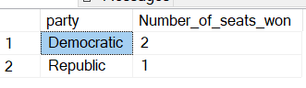

create table customers (id int, first_name varchar(20), last_name varchar(20));

insert into customers values

(1,'Carolyn','O''Lunny'),

(2,'Matteo','Husthwaite'),

(3,'Malessa','Rowseby');

create table campaigns (id int, customer_id int, name varchar(30));

insert into campaigns values

(2,1,'Overcoming Challenges'),

(4,1,'Business Rules'),

(3,2,'YUI'),

(1,3,'Quantitative Finance'),

(5,3,'MMC');

create table events (campaign_id int, status varchar(10));

insert into events values

(1,'Success'),

(1,'Success'),

(2,'Success'),

(2,'Success'),

(2,'Success'),

(2,'Success'),

(2,'Success'),

(3,'Success'),

(3,'Success'),

(3,'Success'),

(4,'Success'),

(4,'Success'),

(4,'Failure'),

(4,'Failure'),

(5,'Failure'),

(5,'Failure'),

(5,'Failure'),

(5,'Failure'),

(5,'Failure'),

(5,'Failure'),

(4,'Success'),

(5,'Success'),

(5,'Success'),

(1,'Failure'),

(1,'Failure'),

(1,'Failure'),

(2,'Failure'),

(3,'Failure');

/*Expected Output:

event_type Customer Campaign Total

Success Carolyn O'Lunny Business Rules, Overcoming Challenges 8

Failure Malessa Rowesby MMC, Quantitative Finance 9

*/

select * from customers;

select * from campaigns;

select * from events;

with cte1 as

(select

e.campaign_id,

e.status event_type, concat(c.first_name,' ', c.last_name) Customer, cp.name Campaign

,row_number() over (partition by concat(c.first_name,' ', c.last_name),e.status order by campaign_id ) Total_Campaigns

from events e

join campaigns cp on e.campaign_id=cp.id

join customers c on cp.customer_id=c.id),

cte2 as

(select *,max(Total_Campaigns) over (partition by customer, event_type order by Customer) max from cte1 ),

cte3 as

(select max(total_campaigns) maxx,event_type from cte1

group by event_type),

cte4 as

(select distinct cte2.event_type, cte2.customer, cte2.campaign, cte2.max total

from cte2 join cte3 on cte2.max = cte3.maxx )

select event_type, customer, string_agg(campaign, ',') campaign, total from cte4

group by event_type, customer,total

order by event_type desc ;

----------------------------

with cte1 as

(select

e.status event_type, concat(c.first_name,' ', c.last_name) Customer, cp.name Campaign

--,row_number() over (partition by concat(c.first_name,' ', c.last_name),e.status order by campaign_id ) Total_Campaigns

,count(1) as total

from events e

join campaigns cp on e.campaign_id=cp.id

join customers c on cp.customer_id=c.id

group by e.status, concat(c.first_name,' ', c.last_name), cp.name ),

cte2 as

(select event_type, customer, STRING_AGG (Campaign,',') campaign,sum(total) total

from cte1

group by event_type, customer)

select event_type, customer, campaign, total from

(select *, rank() over (partition by event_type order by total desc) rnk from cte2 ) a

where a.rnk = 1 order by event_type desc ;

with cte1 as

(select distinct r.*, concat(c.first_name,' ',c.last_name) candidate_name

, count(1) over (partition by concat(c.first_name,' ',c.last_name), state order by concat(c.first_name,' ',c.last_name) ) total_count

from results_tab r join candidates_tab c

on c.id= r.candidate_id),

cte2 as

(select candidate_name, string_agg (concat(state,' (', total_count,')'),',') states ,

rank() over (partition by candidate_name order by total_count desc) wins

from cte1

group by candidate_name,total_count)

select candidate_name,

string_agg(case when wins = 1 then states else '' end,'') '1st_place',

string_agg(case when wins = 2 then states else '' end,'') '2nd_place',

string_agg(case when wins = 3 then states else '' end,'') '3rd_place'

from cte2

group by candidate_name

create table persons (person_id varchar(2), parent_id varchar(2), person_status varchar(10));

insert into persons values

('A' ,'X','Alive'),

('B' ,'Y','Dead'),

('X' ,'X1','Alive'),

('Y' ,'Y1','Alive'),

('X1','X2','Alive'),

('Y1','Y2','Dead');

select * from persons ;

--print the number of persons with grand parent alive.

with cte as

(select p1.*, p2.parent_id grand_parent_id from persons p1 join persons p2

on p1.parent_id = p2.person_id)

select count(*) Total_Persons_with_Grand_Parents_Alive

--cte.grand_parent_id, cte.person_id, p.person_status grand_parent_status, cte.person_status

from cte join persons p

on cte.grand_parent_id = p.person_id

where p.person_status='Alive'

---------

select count(1) Total_Persons_with_Grand_Parents_Alive

--c.*, p.parent_id, g.parent_id, g.person_status grand_parent_id

from persons c

join persons p on c.parent_id = p.person_id

join persons g on p.parent_id = g.person_id

where g.person_status = 'Alive'

------------

--Display sum(runs) per each over

--actual challenge is to generate data for 20 overs randomly

create table match_score

(

balls int,

runs int

);

-- Formula for range between 2 numbers. Here we need between 1 & 6. 1 being low number and 6 begin the high number.

-- floor(RANDOM()*(high_no - low_no + 1)) + low_no;

INSERT INTO match_score

SELECT value, floor(rand(value*21378)*6-1)+1

from generate_series (1,120);

--since in sqlserver the rand value is coming same number for all 120 entries...

--added 'seed' as value*21378 (21378 is a random number to get one digit before decimal value

--then selected high_num as 6, low_num as 1... and used floor to round off decimals into numbers

select * from match_score

SELECT RUNS,COUNT(1) FROM match_score GROUP BY RUNS;

UPDATE match_score

SET RUNS = floor(rand()*(2-1))+1

WHERE RUNS = 5;

SELECT sum(runs) FROM match_score ;

with cte as

(SELECT *, ntile(20) over (order by balls) overs FROM match_score)

select overs, sum(runs) from cte group by overs;

13/Nov/2024

Print ‘Active’ if at least one of the status is ‘Active’, Print ‘Inactive’ if all the entries of a parent are ‘Inactive’.

create table parent_status (parent_id int, child_id int, stats varchar(10));

insert into parent_status values

(1,3,'Active'),

(1,4,'Inactive'),

(1,5,'Active'),

(1,6,'Inactive'),

(2,7,'Active'),

(2,8,'Inactive'),

(3,9,'Inactive'),

(4,10,'Inactive'),

(4,11,'Active'),

(5,12,'Inactive'),

(5,13,'Inactive');

select *, rank () over (partition by parent_id order by stats) rnk

from parent_status;

with cte1 as

(select distinct parent_id from parent_status where stats = 'Active')

select distinct p.parent_id, case when p.parent_id in (select parent_id from cte1) then 'Active' else 'Inactive' end status

from parent_status p

select distinct p.parent_id,

case when p.parent_id in

(select p2.parent_id from parent_status p2 where p2.stats='Active')

then 'Acitve' else 'Inactive' end status from parent_status p

select parent_id, min(stats) from parent_status group by parent_id;

select distinct parent_id, stats from

(select parent_id, stats, rank() over (partition by parent_id order by stats) rnk from parent_status) a

where a.rnk=1;

create table lift (id int, capacity int);

insert into lift values (1, 300), (2,350);

create table lift_passengers (passenger_name varchar(30), weight_kg int, lift_id int);

insert into lift_passengers values

('Rahul',85,1),

('Adarsh',73,1),

('Riti',95,1),

('Dheeraj',80,1),

('Vimal',83,2),

('Neha',77,2),

('Priti',73,2),

('Himanshi',85,2);

--print comma separated list of passengers who can be accommodated in each lift without exceeding its capacity.

--The passenger list should be order by their weight in increasing order.

select lift_id, string_agg(passenger_name, ', ') passengers from

(select p.*, l.capacity, sum(weight_kg) over (partition by lift_id order by weight_kg

range between unbounded preceding and current row ) cumulative_weight

from lift_passengers p join lift l on p.lift_id = l.id) k

where k.cumulative_weight <= k.capacity

group by lift_id

--it gives the same result without unbounded clause

/*For pairs of brands in the same year (e.g.: apple/samsung/2020 and samsung/apple/2020)

if custom1 = custom3 and custom2 = custom4 then keep only one pair

if custom1 != custom3 and custom2 != custom4 then keep both the pairs

For brands that do not have pairs, keep all the records */

create table brands (brand1 varchar (15), brand2 varchar(15), year int, custom1 int, custom2 int, custom3 int, custom4 int);

insert into brands values

('apple','samsung',2020, 1,2,1,2),

('samsung','apple',2020, 1,2,1,2),

('samsung','apple',2021, 1,2,5,3),

('apple','samsung',2021, 5,3,1,2),

('goole','',2021,5,9,null,null),

('oneplus','nothing',2022,5,9,6,3);

with cte as

(select case when brand1>brand2 then concat(brand1,brand2,year) else concat(brand2,brand1,year) end pair, * from brands ),

cte1 as

(select *, lead(pair) over (partition by pair order by pair) next_rec from cte),

cte2 as

(select *, case when next_rec is not NULL and custom1= custom3 and custom2=custom4 then 1 else 0 end dup_flag from cte1)

select brand1, brand2, year, custom1, custom2, custom3, custom4 from cte2 where dup_flag !=1 order by year

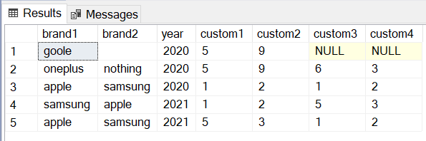

2024-11-21:

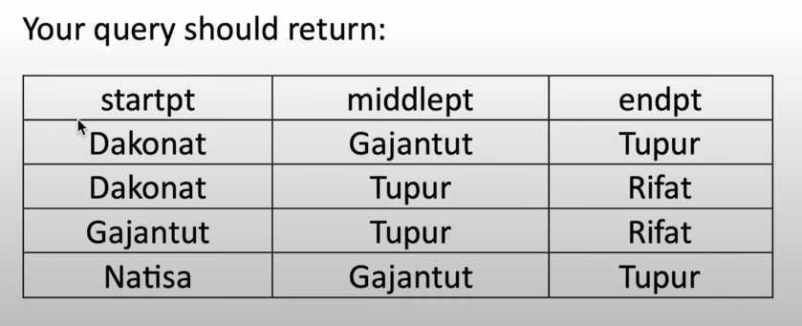

create table mountain_huts

(

id integer not null unique,

name varchar(40) not null unique,

altitude integer not null

);

insert into mountain_huts values (1, 'Dakonat', 1900);

insert into mountain_huts values (2, 'Natisa', 2100);

insert into mountain_huts values (3, 'Gajantut', 1600);

insert into mountain_huts values (4, 'Rifat', 782);

insert into mountain_huts values (5, 'Tupur', 1370);

drop table if exists trails;

create table trails

(

hut1 integer not null,

hut2 integer not null

);

insert into trails values (1, 3);

insert into trails values (3, 2);

insert into trails values (3, 5);

insert into trails values (4, 5);

insert into trails values (1, 5);

**Solution:**

with cte1 as

(select t1.hut1, m1.name source, m1.altitude altitude1, t1.hut2, m2.name destination, m2.altitude altitude2,

case when m1.altitude > m2.altitude then 1 else 0 end altitude_flag

from mountain_huts m1 join

trails t1 on m1.id = t1.hut1

join mountain_huts m2 on m2.id = t1.hut2 ),

--Now we order the source and destination based on source always being on higher altitude, if not we swap the values.

cte2 as

(select case when altitude_flag =1 then hut1 else hut2 end hut1,

case when altitude_flag=1 then source else destination end source,

case when altitude_flag=1 then altitude1 else altitude2 end altitude1,

case when altitude_flag=1 then hut2 else hut1 end hut2,

case when altitude_flag=1 then destination else source end destination,

case when altitude_flag=1 then altitude2 else altitude1 end altitude2

from cte1 )

select c1.source source, c1.destination mid_point, c2.destination end_point

from cte2 c1 join cte2 c2 on c1.destination = c2.source

order by c1.source

2024-11-22:

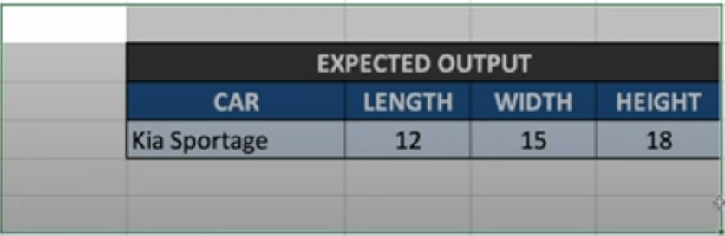

create table footer (id int, car varchar(15), length int, breadth int, height int);

insert into footer values

(1,'Hyundai',15,6,NULL),

(2,'',NULL,NULL,20),

(3,'',12,8,15),

(4,'Toyota',NULL,15,NULL),

(5,'Kia',NULL,NULL,18);

--Solution-1:

select * from

(select top 1 car from footer where car is not null order by id desc) car

cross join

(select top 1 length from footer where length is not null order by id desc) length

cross join (select top 1 breadth from footer where breadth is not null order by id desc ) breadth

cross join (select top 1 height from footer where height is not null order by id desc ) height ;

Solution-2:

with cte as

(select id, car, length,

case when length is not null then 1 else 0 end length_flag ,

sum(case when length is not null then 1 else 0 end) over (order by id) length_segment,

breadth,

case when breadth is not null then 1 else 0 end breadth_flag ,

sum(case when breadth is not null then 1 else 0 end) over (order by id) breadth_segment,

height,

case when height is not null then 1 else 0 end height_flag ,

sum(case when height is not null then 1 else 0 end) over (order by id) height_segment

from footer)

select top 1 --*

car, first_value(length) over (partition by length_segment order by id) new_length,

first_value(breadth) over (partition by breadth_segment order by id) new_breadth,

first_value(height) over (partition by height_segment order by id) new_height

from cte

order by id desc

12/02/2024:

drop table if exists salary;

create table salary

(

emp_id int,

emp_name varchar(30),

base_salary int

);

insert into salary values(1, 'Rohan', 5000);

insert into salary values(2, 'Alex', 6000);

insert into salary values(3, 'Maryam', 7000);

drop table if exists income;

create table income

(

id int,

income varchar(20),

percentage int

);

insert into income values(1,'Basic', 100);

insert into income values(2,'Allowance', 4);

insert into income values(3,'Others', 6);

drop table if exists deduction;

create table deduction

(

id int,

deduction varchar(20),

percentage int

);

insert into deduction values(1,'Insurance', 5);

insert into deduction values(2,'Health', 6);

insert into deduction values(3,'House', 4);

drop table if exists emp_transaction;

create table emp_transaction

(

emp_id int,

emp_name varchar(50),

trns_type varchar(20),

amount numeric

);

insert into emp_transaction

select s.emp_id, s.emp_name, x.trns_type

, case when x.trns_type = 'Basic' then round(base_salary * (cast(x.percentage as decimal)/100),2)

when x.trns_type = 'Allowance' then round(base_salary * (cast(x.percentage as decimal)/100),2)

when x.trns_type = 'Others' then round(base_salary * (cast(x.percentage as decimal)/100),2)

when x.trns_type = 'Insurance' then round(base_salary * (cast(x.percentage as decimal)/100),2)

when x.trns_type = 'Health' then round(base_salary * (cast(x.percentage as decimal)/100),2)

when x.trns_type = 'House' then round(base_salary * (cast(x.percentage as decimal)/100),2) end as amount

from salary s

cross join (select income as trns_type, percentage from income

union

select deduction as trns_type, percentage from deduction) x;

select * from salary;

select * from income;

select * from deduction;

select * from emp_transaction;

select employee, sum(basic) basic, sum(allowance) allowance, sum(others) others, sum(basic+allowance+others) gross

, sum(Insurance) Insurance, sum(Health) Health, sum(House) House, sum(Insurance+Health+House) Total_Deductions,

sum(basic+allowance+others) - sum(Insurance+Health+House) NetPay from

(select emp_name EMPLOYEE,

sum(coalesce(case when trns_type = 'Basic' then amount end,0)) BASIC ,

sum(coalesce(case when trns_type = 'Allowance' then amount end,0)) ALLOWANCE

, sum(coalesce(case when trns_type = 'Others' then amount end,0)) OTHERS

,sum(coalesce(case when trns_type = 'Insurance' then amount end,0)) Insurance ,

sum(coalesce(case when trns_type = 'Health' then amount end,0)) Health

, sum(coalesce(case when trns_type = 'House' then amount end,0)) House

from emp_transaction

group by emp_name, trns_type, amount ) a

group by employee

,

(case when trns_type = 'Basic' then amount end +

case when trns_type = 'Allowance' then amount end + case when trns_type = 'Allowance' then amount end )

GROSS

group by emp_name, trns_type

12/03/2024:

create table input_marks (test_id int, marks int);

insert into input_marks values

(100,55),

(101,55),

(102,60),

(103,58),

(104,40),

(105,50);

--Output-1:

select test_id, marks from (

select *, lag(marks) over (order by test_id) prev_marks from input_marks ) a

where marks > prev_marks or prev_marks is NULL

select test_id, marks from (

select *, lag(marks,1,0) over (order by test_id) prev_marks from input_marks ) a

where marks > prev_marks

--Output-2:

select test_id, marks from (

select *, lag(marks,1,marks) over (order by test_id) prev_marks from input_marks ) a

where marks > prev_marks

20250127:

/*Netflix (Hard Level) hashtag#SQL Interview Question/*

Find the genre of the person with the most number of oscar winnings.

If there are more than one person with the same number of oscar wins,

return the first one in alphabetic order based on their name.

Use the names as keys when joining the tables.

By solving this, you'll learn how to use join. Give it a try and share the output!

𝐒𝐜𝐡𝐞𝐦𝐚 𝐚𝐧𝐝 𝐃𝐚𝐭𝐚𝐬𝐞𝐭:

CREATE TABLE nominee_information(name varchar(20), amg_person_id varchar(10), enre varchar(10), birthday datetime, id int);

INSERT INTO nominee_information VALUES('Jennifer Lawrence','P562566','Drama','1990-08-15',755),('Jonah Hill','P418718','Comedy','1983-12-20',747),('Anne Hathaway', 'P292630','Drama', '1982-11-12',744),('Jennifer Hudson','P454405','Drama', '1981-09-12',742),('Rinko Kikuchi', 'P475244','Drama', '1981-01-06', 739);

CREATE TABLE oscar_nominees(year int, category varchar(30), nominee varchar(20), movie varchar(30), winner int, id int);

INSERT INTO oscar_nominees VALUES(2008,'actress in a leading role','Anne Hathaway','Rachel Getting Married',0,77),(2012,'actress in a supporting role','Anne Hathaway','LesMisrables',1,78),(2006,'actress in a supporting role','Jennifer Hudson','Dreamgirls',1,711),(2010,'actress in a leading role','Jennifer Lawrence','Winters Bone',1,717),(2012,'actress in a leading role','Jennifer Lawrence','Silver Linings Playbook',1,718),(2011,'actor in a supporting role','Jonah Hill','Moneyball',0,799),(2006,'actress in a supporting role','Rinko Kikuchi','Babel',0,1253);

*/

select * from oscar_nominees;

select * from nominee_information;

with t1 as

(select distinct nominee, count(1) over (partition by nominee order by nominee) cnt from oscar_nominees),

t2 as

(select max(cnt) max from t1)

select top 1 top_genre from nominee_information join t1 on name = nominee

join t2 on cnt = max;

20250128:

Write a query that'll identify returning active users.

A returning active user is a user that has made a second purchase within 7 days of any other of their purchases.

Output a list of user_ids of these returning active users.

𝐒𝐜𝐡𝐞𝐦𝐚 𝐚𝐧𝐝 𝐃𝐚𝐭𝐚𝐬𝐞𝐭:

CREATE TABLE amazon_transactions(id int, user_id int, item varchar(15), created_at datetime, revenue int);

INSERT INTO amazon_transactions VALUES (1,109,'milk','2020-03-03 00:00:00',123),(2,139,'biscuit','2020-03-18 00:00:00', 421), (3,120,'milk','2020-03-18 00:00:00',176), (4,108,'banana','2020-03-18 00:00:00',862), (5,130,'milk','2020-03-28 00:00:00',333), (6,103,'bread','2020-03-29 00:00:00',862), (7,122,'banana','2020-03-07 00:00:00',952), (8,125,'bread','2020-03-13 00:00:00',317), (9,139,'bread','2020-03-30 00:00:00',929), (10,141,'banana','2020-03-17 00:00:00',812), (11,116,'bread','2020-03-31 00:00:00',226), (12,128,'bread','2020-03-04 00:00:00',112), (13,146,'biscuit','2020-03-04 00:00:00',362), (14,119,'banana','2020-03-28 00:00:00',127), (15,142,'bread','2020-03-09 00:00:00',503), (16,122,'bread','2020-03-06 00:00:00',593), (17,128,'biscuit','2020-03-24 00:00:00',160), (18,112,'banana','2020-03-24 00:00:00',262), (19,149,'banana','2020-03-29 00:00:00',382), (20,100,'banana','2020-03-18 00:00:00',599);

select * from amazon_transactions order by user_id

insert into amazon_transactions values (21, 122, 'milk','2020-03-14 00:00:00',113), (22, 139,'milk','2020-04-05 00:00:00.000',113);

with cte as

(select user_id,

datediff(day, created_at, lead(created_at) over (partition by user_id order by created_at)) returning_flag

from amazon_transactions )

select distinct user_id from cte where returning_flag < 7;

20250129

/*You are given a table of product launches by company by year.

Write a query to count the net difference between the number of products companies launched in 2020

with the number of products companies launched in the previous year.

Output the name of the companies and a net difference of net products released for 2020

compared to the previous year.

🔍 By solving this, you'll learn how to handle aggregation function. Give it a try! 👇

𝐒𝐜𝐡𝐞𝐦𝐚 𝐚𝐧𝐝 𝐃𝐚𝐭𝐚𝐬𝐞𝐭:

CREATE TABLE car_launches(year int, company_name varchar(15), product_name varchar(30));

INSERT INTO car_launches VALUES(2019,'Toyota','Avalon'),(2019,'Toyota','Camry'),(2020,'Toyota','Corolla'),(2019,'Honda','Accord'),(2019,'Honda','Passport'),(2019,'Honda','CR-V'),(2020,'Honda','Pilot'),(2019,'Honda','Civic'),(2020,'Chevrolet','Trailblazer'),(2020,'Chevrolet','Trax'),(2019,'Chevrolet','Traverse'),(2020,'Chevrolet','Blazer'),(2019,'Ford','Figo'),(2020,'Ford','Aspire'),(2019,'Ford','Endeavour'),(2020,'Jeep','Wrangler')

*/

with cte as

(select

year, company_name,

count(1) current_year_release_count,

lag(count(1),1,0) over (partition by company_name order by year) prev_year_release_count,

count(1) - lag(count(1),1,0) over (partition by company_name order by year) net_difference

from car_launches

group by year, company_name )

select company_name, net_difference

from cte

where year = 2020

order by net_difference desc

20250130:

Nvidia, Microsoft (Medium Level) [hashtag#SQL](https://www.linkedin.com/feed/hashtag/?keywords=sql&highlightedUpdateUrns=urn%3Ali%3Aactivity%3A7290587048665661440) Interview Question — Solution  
  
Find the number of transactions that occurred for each product. Output the product name along with the corresponding number of transactions and order records by the product id in ascending order. You can ignore products without transactions.  
  
🔍 By solving this, you'll learn how to use join with grouping. Give it a try and share the output! 👇  
  
𝐒𝐜𝐡𝐞𝐦𝐚 𝐚𝐧𝐝 𝐃𝐚𝐭𝐚𝐬𝐞𝐭:  
CREATE TABLE excel_sql_inventory_data (product_id INT,product_name VARCHAR(50),product_type VARCHAR(50),unit VARCHAR(20),price_unit FLOAT,wholesale FLOAT,current_inventory INT);  
  
INSERT INTO excel_sql_inventory_data (product_id, product_name, product_type, unit, price_unit, wholesale, current_inventory)   
VALUES(1, 'strawberry', 'produce', 'lb', 3.28, 1.77, 13),(2, 'apple_fuji', 'produce', 'lb', 1.44, 0.43, 2),(3, 'orange', 'produce', 'lb', 1.02, 0.37, 2),(4, 'clementines', 'produce', 'lb', 1.19, 0.44, 44),(5, 'blood_orange', 'produce', 'lb', 3.86, 1.66, 19);  
  
CREATE TABLE excel_sql_transaction_data (transaction_id INT PRIMARY KEY,time DATETIME,product_id INT);  
  
INSERT INTO excel_sql_transaction_data (transaction_id, time, product_id)   
VALUES(153, '2016-01-06 08:57:52', 1),(91, '2016-01-07 12:17:27', 1),(31, '2016-01-05 13:19:25', 1),(24, '2016-01-03 10:47:44', 3),(4, '2016-01-06 17:57:42', 3),(163, '2016-01-03 10:11:22', 3),(92, '2016-01-08 12:03:20', 2),(32, '2016-01-04 19:37:14', 4),(253, '2016-01-06 14:15:20', 5),(118, '2016-01-06 14:27:33', 5);



Solution:

with cte as

(

select *,

case when substring(Day_Indicator,1,1) = '1' and datename(dw, Dates) = 'Monday' then 'Y'

when substring(Day_Indicator,2,1) = '1' and datename(dw, Dates) = 'Tuesday' then 'Y'

when substring(Day_Indicator,3,1) = '1' and datename(dw, Dates) = 'Wednesday' then 'Y'

when substring(Day_Indicator,4,1) = '1' and datename(dw, Dates) = 'Thursday' then 'Y'

when substring(Day_Indicator,5,1) = '1' and datename(dw, Dates) = 'Friday' then 'Y'

when substring(Day_Indicator,6,1) = '1' and datename(dw, Dates) = 'Saturday' then 'Y'

when substring(Day_Indicator,7,1) = '1' and datename(dw, Dates) = 'Sunday' then 'Y' else 'N'

end flag from Day_Indicator )

select Product_ID, Day_Indicator,Dates

from cte

where flag='Y';

20250131:



create table JD (row_id int, job_role varchar(20), skills varchar(20));

insert into JD values

(1,'Data Engineer','SQL'),

(2,'','Python'),

(3,'','AWS'),

(4,'','Snowflake'),

(5,'','Apache Spark'),

(6,'Web Developer','Java'),

(7,'','HTML'),

(8,'','CSS'),

(9,'','Python'),

(10,'Data Scientist','Machine Learning'),

(11,'','Deep Learning'),

(12,'','Tableau');

with cte as

(select *, sum(case when job_role <> ' ' then 1 else 0 end) over (order by row_id) segment from JD )

select row_id, first_value(job_role) over (partition by segment order by row_id) job_role, skills from cte

20250203:



create table merge_customers (customer_id int, dates date, product_id int);

insert into merge_customers values

(1,'2024-02-18',101),

(1,'2024-02-18',102),

(1,'2024-02-19',101),

(1,'2024-02-19',103),

(2,'2024-02-18',104),

(2,'2024-02-18',105),

(2,'2024-02-19',101),

(2,'2024-02-19',106);

select dates, cast (product_id as varchar) product_id from merge_customers

union

select dates, string_agg(cast (product_id as varchar),',') product_id from merge_customers

group by dates, customer_id

order by dates, product_id

20250203:

/*Given the users' sessions logs on a particular day, calculate how many hours each user was active that day.

--Note: The session starts when state=1 and ends when state=0.

--🌀By solving this, you'll learn how to use Cte, Windows Function, Group by. Give it a try and share the output! 👇

𝐒𝐜𝐡𝐞𝐦𝐚 𝐚𝐧𝐝 𝐃𝐚𝐭𝐚𝐬𝐞𝐭*/

CREATE TABLE cust_tracking (cust_id VARCHAR(50), state BIGINT, timestamp DATETIME);

INSERT INTO cust_tracking (cust_id, state, timestamp) VALUES ('101', 1, '2024-01-10 08:00:00'), ('101', 0, '2024-01-10 10:30:00'), ('101', 1, '2024-01-10 14:00:00'), ('101', 0, '2024-01-10 15:45:00'), ('102', 1, '2024-01-10 09:15:00'), ('102', 0, '2024-01-10 12:00:00'), ('103', 1, '2024-01-10 07:00:00'), ('103', 0, '2024-01-10 09:30:00'), ('103', 1, '2024-01-10 13:00:00'), ('103', 0, '2024-01-10 16:00:00');

with cte as

(select *, lead(timestamp) over (partition by cust_id order by cust_id) end_time from cust_tracking)

select cust_id,

CONVERT(VARCHAR(5),

DATEADD(minute,

sum(

datediff(MINUTE, timestamp,end_time)

),0

),114

)

hours_used from cte where state=1 group by cust_id

/*In the code above, the "Date Serial Number" of "0" has been used in DATEADD function. "0" is the base date of "1900-01-01' .

The CONVERT uses format # 114 or (108 can also be used) to format that date and time in the 24 hour format of hh:mi:ss and dumps that to a VARCHAR(5) datatype for display purposes.

You may observe longer date time values in the output if you increase VARCHAR size.

*/

20250204:

--since in sql we can only have one column header, we ignore the higher ‘level’ header.

create table client_auto_repairs (client varchar(2), auto varchar(2), repair_date int, indicator varchar(10), value varchar(10));

insert into client_auto_repairs values

('c1','a1',2022,'level','good'),

('c1','a1',2022,'velocity','90'),

('c1','a1',2023,'level','regular'),

('c1','a1',2023,'velocity','80'),

('c1','a1',2024,'level','wrong'),

('c1','a1',2024,'velocity','70'),

('c2','a1',2022,'level','good'),

('c2','a1',2022,'velocity','90'),

('c2','a1',2023,'level','wrong'),

('c2','a1',2023,'velocity','50'),

('c2','a2',2024,'level','good'),

('c2','a2',2024,'velocity','80');

with cte as

(select v.client, v.auto, v.repair_date, l.indicator l_indicator, l.value level , v.indicator v_indicator, v.value velocity

from client_auto_repairs v join client_auto_repairs l

on v.client = l.client and v.auto = l.auto and v.repair_date = l.repair_date

where l.indicator = 'level' and v.indicator = 'velocity')

select velocity,

sum(case when level = 'good' then 1 else 0 end) good,

sum(case when level = 'wrong' then 1 else 0 end) wrong,

sum(case when level = 'regular' then 1 else 0 end) regular

from cte

group by velocity

20250205:

create table outliers (hotel varchar(20), year int, rating decimal(5,2));

--drop table outliers ;

insert into outliers values

('Radisson Blu',2020,4.8),

('Radisson Blu',2021,3.5),

('Radisson Blu',2022,3.2),

('Radisson Blu',2023,3.4),

('Intercontinental',2020,4.2),

('Intercontinental',2021,4.5),

('Intercontinental',2022,1.5),

('Intercontinental',2023,3.8);

with cte as

(select *,

abs(rating - avg(rating) over (partition by hotel order by year

range between unbounded preceding and unbounded following )) average

from outliers),

cte_rank as

(select *,

rank() over (partition by hotel order by average desc ) rnk

from cte )

select hotel , year, rating from cte_rank

where rnk > 1

order by hotel desc , year

